Gas Countertop hotplate

This manual contains important information regarding
your purchased equipment. Please read the manual thoroughly
prior to equipment set-up, operation and maintenance.
Failure to comply with regular maintenance guidelines
outlined in this manual may void the warranty. Please keep it for future reference after installation and do not throw it away!
This is a universal installation and operation instruction book which would apply to different models.
PLEASE READ!!!

WARNINGS
• Do not store or use gasoline or other flammable vapors or liquids in the vicinity of this or any other equipment.
• Improper installation, adjustment, alteration, service or maintenance can cause property damage, injury or death.
• Read the installation and maintenance instructions thoroughly before installing or servicing this equipment.
• Have the equipment installed by a qualified installer in accordance with all federal, state and local codes.
• Do not install or use without all 4 legs.
• This equipment is for use in non-combustible locations only.
• Do not obstruct the flow of combustion and ventilation air.
• Do not spray controls or the outside of the equipment with liquids or cleaning agents
• Allow for hot parts to cool before cleaning or moving.
• This equipment should only be used in a flat, level position.
• Do not operate unattended.
• Any loose dirt or metal particles that are allowed to enter the gas lines on this equipment will damage the valve and affect its operation.
• If you smell gas, follow the instructions provided by the gas supplier. Do not touch any electrical switch; do not try to light the burner; do not use a telephone within close proximity.
• Never attempt to move grates while cooking.
SET UP
1. Remove all packing material and tape, as well as any protective plastic from the equipment.
2. Place the equipment in the desired position and height.
3. Install the four (4) legs onto the equipment.
4. Clean and dry the equipment thoroughly before using.
INSTALLATION:
The installation of this equipment must conform with local codes, or with the National Gas Code, ANSIZ223.1/NFPA 54, or the
Natural Gas and Propane Installation Code, CSA B149.1, as applicable.
• The equipment and its individual shutoff valve must be disconnected from the gas supply piping system during any pressure testing of that system at test pressures in excess of ½ psi (3.5 kPa).
• The equipment must be isolated from the gas supply piping system by closing its individual manual shutoff valve during any pressure testing of the gas supply piping system at test pressures equal to or less than ½ psi (3.5 kPa).
Clearance and positioning around the equipment:
• This equipment must be installed adjacent to non-combustible surfaces only with a minimum spacing of 6” from all sides. This equipment must be a distance of 6” from other equipment. The equipment must have the 4” legs installed and be placed on a noncombustible surface.
Air Supply and ventilation:
• The area in front and around the equipment must be kept clear to avoid any obstruction of the flow of combustion and ventilation air.
• Adequate clearance must be maintained at all times in front of and at the sides of the equipment for servicing and proper ventilation.
Pressure Regulator:
• All commercial cooking equipment must have a pressure regulator on the incoming service line for safe and efficient operation. The regulator provided for this equipment is adaptable for both Natural gas and LP gas.

Check the gas supply pressure after installation.
Gas supply pressure can be measured with a liquid-filled pressure gauge (e.g. a U-shaped pressure gauge, minimum scale division 0.1mbar) or a digital gauge. Procedure as follows:

- Remove the panel, unscrew the screw on the pressure port (Picture 1);
- Place the pressure gauge;
- Start up the appliance by following the instructions in the user’s manual;
- Check the supply pressure;
- After the check, remove the pressure gauge;
- Replace the sealing screw.

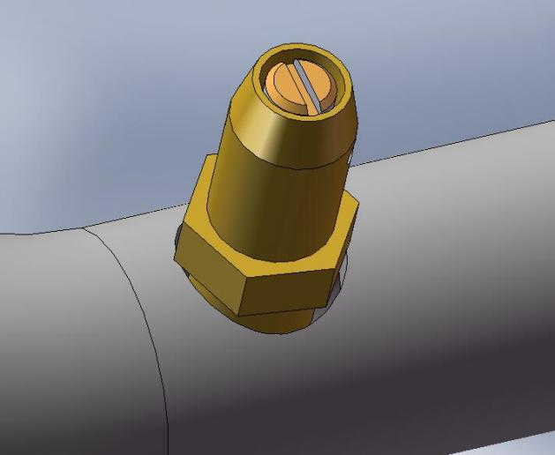
Picture 1
pressure port
sealing screw

PROPANE GAS CONVERSION
This hotplate is shipped from the factory equipped with fixed burner orifices for natural gas operation. The burner orifices required to convert the hotplate to propane gas are shipped with the hotplate in the shipping packaging. It is recommended that a trained gas service technician with the necessary tools, instruments and skills perform the conversion.
To convert to propane, following steps must be completed:

Switch off the gas at the main supply valve and allow the unit to cool down before commencing with the conversion.
Take off the front plate to expose the injector and control valve.
Change the main burner injector:
Loosen and remove the brass orifice located on the end of the burner with a wrench.
Replace with the new orifice from the conversion kit, first applying a small amount of jointing paste to the thread on the end of the nozzle holder, this will ensure a good gas tight seal.

OPERATION:
Before initial use, turn the gas control knob to the maximum setting and allow the equipment to burn-in for 20 minutes.
Seeing smoke coming from the cooking surface is normal during burn-in. After 20 minutes of burn-in, equipment is ready for use.
1. To ignite the burners, depress and turn the gas control knob to high position
2. The valve should always be set at maximum positions. If it is set in the middle positions, this might cause pressure drop after the nozzle, thus leading to poor mixing of gas and air. The burners might have strong yellow tips of flame.
3. After cooking is done, please turn the valve to off position.
CLEANING:
To maintain the appearance and increase the service life, clean your equipment daily.
DO NOT clean equipment with steel wool.
1. Allow the equipment to cool completely before cleaning.
2. Using a wire brush, scrape the grill grate(s) to remove any food residue.
3. To clean equipment, use either a damp cloth, sponge with soapy water or a metal scraper.
4. Dry grates thoroughly to prevent rusting.
5. Empty and clean the drip tray.
MAINTENANCE:
• A qualified service company should check the unit for safe and efficient operation on an annual basis.
• Gas piping shall be a certain size and installed to provide a supply of gas sufficient to meet the full gas input of the equipment.
• A manual shut off valve should be installed upstream from the manifold within 4 ft. (1.2m) of the equipment and in a position where it can be reached in the event of an emergency.
• Check entire gas piping system for leaks every so often. Using a gas leak detector or soapy water solution is recommended.
• Install equipment under efficient exhaust hood with flameproof filters with a distance of no less than 4 feet between the top of the equipment and the filters or any other combustible materials.
*Shipped setup for Natural Gas and includes a kit for conversion to LPG.

Toubleshooting：
Burner does not come on when the control knob is turned on | A. Problem with gas valve. (Call for service). B. Pilot burner not lit. C. Low gas pressure. (Call for service)
Too much heat | A. Burner valves adjusted too high B. Faulty ventilation C. Overrated gas pressure D. Improperly adjusted burner
Uneven heat side to side | A. Burner valves improperly adjusted B. Appliance is not level side to side C. Improperly adjusted burner
Uneven heat front to back | A. Appliance is not level front to back B. Faulty ventilation C. Improperly adjusted burner
Pilot burner will not stay lit | A. Pilot flame is set too low. Adjust pilot to allow for gas flow. B. Obstruction in pilot orifice C. Low gas pressure. (Call for Service).
Yellow burner flames | A. Open burner shutters until flames are blue
Lifting burner flames | A. Close burner shutters until flames touch burner
Fluctuating gas pressure | A. Check for clogged vent on regulator

Dimensions:
Model | Height | Width | Depth | Weight | Gas Cons MJ/h
JUS-TR-2 | 400mm | 650mm | 437mm | 23KG | 49 NG | 47 ULPG
JUS-TR-4 | 605mm | 650mm | 437mm | 38KG | 98 NG | 94 ULPG
Gas Connection at right side rear 50mm from side, 150mm from top

Technical Information:
Gas:
Burner : griddle | Natural Gas | ULPG
Gas Consumption MJ/h | 24.5 / burner | 23.5 / burner
Injector Size mm | 2.2 | 1.3
Test Point Pressure kPa | 1.0kPa | 2.65kPa
Inlet Pressure Range KPA | 1.13- 1.2 KPA | 2.75- 2.80 KPA

J

