Induction GRILL Series User Manual

● Reminder: Please keep this product manual properly for reference. If the product is improved in the future, no notice will be given.
● Please read the product manual carefully before using.
Contents
I. Safety regulations
II.Maintenance& Inspection
III.Product description&Technical parameters
IV.Architectural feature
V. Installation steps
VI.Operation& Precautions
VII.Error code
VIII.Storage& Transportation
IX.Unpacking and inspection

Welcome to buy our commercial Induction GRILL series. Easy-to-understand operating instructions will save your time and energy studying how to cook food. You only need to select the corresponding food type and desired cooking method, and move gently. With two hands and a simple button, you can use our commercial induction hobs to obtain excellent cooking results. There is no need to enter complex programming operations at all.

This manual describes all the features, structure and methods of use of commercial induction GRILL. For special non-standard products, please read and use the description of this manual and the additional manuals. For non-standard products with only changes in size or material, no additional description will be made. In order to ensure that you can use this product correctly and avoid unnecessary troubles, please read this manual carefully before use to familiarize yourself with this product, and keep the manual properly for reference at any time.

Wish you enjoy using it!

In order to ensure the safe and reliable operation of this product, please designate someone as the operation manager of this product. When this product fails, please report it to the manager immediately and contact the company.

I. Safety regulations
Warning!
●Incorrect installation, operation, maintenance, or cleaning of the equipment, as well as changes that can cause damage, injury, or casualties. Please read the instructions carefully before starting the installation.
●It is not allowed to cook food containing flammable substances (such as food containing alcohol). Substances with low ignition point may ignite spontaneously--Risk of fire!
●Do not place any flammable or combustible substances near the equipment--Risk of fire!
●Please make sure that there are no residues of cleaning tablets in the cooking cavity before using the appliance for cooking. If there are residues, please clean and rinse--there is a risk of corrosion!
Danger-High pressure!
●Inspection, maintenance& repair work can only be carried out by professionally trained professionals.
●The power supply of the equipment must be cut off during cleaning, inspection, maintenance and repair work.
●The range of movement of the equipment with wheels (executable equipment) must be restricted to ensure that it will not damage the wires, water pipes and drainage pipes during the movement. Before moving the device, you must cut off the power connection correctly. After the equipment is moved back to its original position, the mobile safety device and power cord must be connected as required.
●In order to ensure that your equipment has no technical problems, at least an authorized service partner should perform equipment maintenance at least once a year.
Attention!
●If the power cord is damaged, in order to avoid danger, it must be replaced by professionals from the manufacturer, its maintenance department or similar departments.
●The power cord should be an oil-resistant sheathed cable, not lighter than ordinary neoprene or other equivalent synthetic rubber sheathed cords (YZW).
●The fixed wiring of the power cord connection must be equipped with a disconnect device (leakage protection switch) with a contact distance greater than 30mm according to the wiring rules.
●Users with pacemakers should contact the manufacturer before operating the stove and obtain the manufacturer’s consent before using it.
●This manual does not apply to people (including children) who have physical, sensory, or intellectual defects, or lack of experience and knowledge.
●Before cleaning the stove, the user should make sure that the power has been turned off and the stove has cooled down, and water jets should not be used for cleaning.
●Repair work can only be done by personnel trained or recommended by the manufacturer.
●Equipotential meaning:Equipotential bonding in electrical appliances is to connect exposed metal and conductive parts of electrical devices and other devices in electrical appliances with artificial or natural grounding conductors to reduce potential differences (reduce and prevent the risk of electric shock).
●Non-ionizing electromagnetic radiation: indicates higher than conventional, potentially dangerous non-ionizing radiation.
●Dangerous voltage: There are live parts with a working voltage greater than 250V.
How to deal with the smell of gas:
●Turn off the device power switch immediately
●Do not touch any electrical switches
●Ventilate the room
●Avoid open flames and sparks
●Notify the person in charge immediately
●Please keep this manual in a place where the user of the equipment can read it at any time! Children, persons with physical, sensory, or mental impairments, or persons with a lack of knowledge and knowledge are not allowed to operate the equipment, unless such persons are in Under the supervision of a person responsible for safety.

II.Maintenance& Inspection
caution!
●If the equipment is not cleaned or cleaned inadequately, the remaining grease or food residues may burn on the cooking surface--risk of fire!
●In order to avoid corrosion of the cooking surface, your equipment must be cleaned every day.
●In order to avoid corrosion, please apply vegetable oil or grease to the cooking surface regularly (about once every two weeks).
●Do not use a high-pressure cleaner to clean the equipment.
●Do not use acid to treat the equipment, otherwise the inert layer of nickel-chromium alloy steel will be damaged, which may cause discoloration of the equipment.
●Please only use cleaning agents for special equipment, other types of cleaning agents may cause damage and impair your right of protection.
●Do not use abrasives or scratching cleaners.
●In order to maintain the high quality of stainless steel, and for sanitary reasons and to avoid operational failures, your equipment must be cleaned every day or according to actual usage.
●In order to keep the movement system in a relatively clean and dry environment during long-term operation, an air filter device is specially designed, that is, the air filter under the furnace bottom, which must be replaced every 2 months. Please see the note on the side of the induction cooker. matter.
●Keep the furnace as clean as possible.
●Do not use water jets for cleaning in the process of cleaning appliances.
●The control system is composed of an operation panel and a control main board. The operation panel adopts DC 5 V power supply. The PCB board and buttons are moisture-proof, anti-corrosion, and treated to ensure normal use in humid, high and low temperature environments; the panel adopts touch control mode, even if frequently There is no damage to the control buttons when the buttons are touched.
●The main board adopts a dual MCU architecture, the main control MCU1 adopts an industrial-grade ARM32-bit microprocessor, and the temperature acquisition MCU2 adopts an imported integrated IC to ensure that there is no temperature difference in high heat, cold, and humid environments.

● advantageous functions
●Safety：Isolation induction heating, no open flame, over-temperature protection of the pot body dry burning, to prevent flammability, explosion, leakage and other phenomena.
●High-efficiency：It has a fast heating function, which saves more than half of the time than electric heating and gas, reduces manual care, and improves production efficiency.
●Environmental protection：Pure green energy, zero carbon emissions, no consumables, easy to clean, and no heat radiation to the surrounding environment.
●Durable：The body material is anti-corrosion material, which guarantees no deformation during use to the greatest extent. no hightemperature aging, no consumables, no wearing parts in electrical parts.

III.Product description&Technical parameters

Product description | Model No.: | Voltage & Power
INDUCTION GRILL | EGP9-800 | 3N~ 380V-420V~50Hz-60Hz 10.0KW

V. Architectural feature:
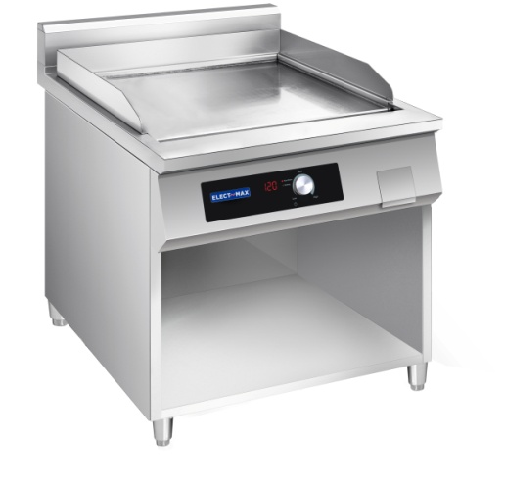
1 | Rear Plate
2 | Heating plate
3 | Oil pocket
4 | Control panel
5 | Oil baffle
6 | Feet

●The body of the induction GRILL is made of high-quality all-stainless steel with meticulous and user-friendly design. The appearance is clean and beautiful, and has excellent anti-corrosion ability; the internal frame is supported, which is firm and durable;
●Easy to operate: One-button operation and digital display are simple and clear, intelligent computer control technology.
●Ultra-quiet system design, no combustion exhaust gas, smoke and dust emission heat, low energy loss, low room temperature, fresh air, greatly improved kitchen environment, and the health of the chef is guaranteed, creating a quiet and comfortable cooking environment。
●Perfect function: It can replace the traditional cooking utensils such as frying, grilling and other cooking functions, especially suitable for occasions where fuel supply and safety conditions are restricted.
●Reduce matching: reduce the engineering workload and part of the investment for some air supply and exhaust devices. Eliminates the construction and supporting costs of the gas pipeline, and saves the space: small size, high
thermal efficiency, and fast heating speed, which greatly saves the area of the site.
●Precise temperature control: The use of large-scale power adjustment and advanced computer control technology can accurately control the cooking temperature, which saves energy and ensures the deliciousness of the food.

VI.Installation steps

1, Put the location
●Place the induction GRILL on a flat ground;
●Fix the support layer and pins of the induction GRILL under the body of the unit ;
●The following are the places where the equipment cannot be installed:
Places subject to direct sunlight, rain, heavy vibration, high-voltage lines nearby, excessive temperature and humidity, and frequent interference (high-voltage, high-frequency).

2, Power connection
●When the distance between the control leakage switch and the corresponding device is within 10m, the connection line between the device and the switch can be configured according to the following instructions. When it exceeds 10m, please use a larger type of wire according to the actual situation to offset the loss and heat.
●The rear panel of the induction cooker is equipped with a power cord connection, and the corresponding phase line is fixed in the screw fixing column of the junction box according to the requirements during installation:
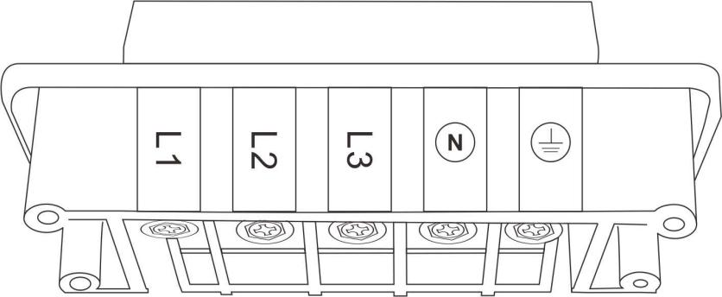
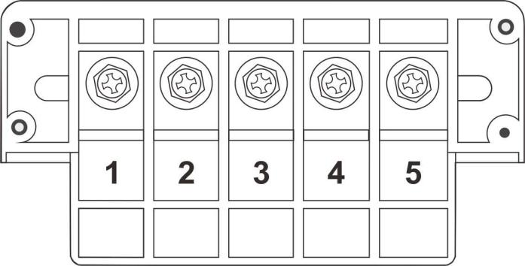

VII.Operation& Precautions

Knob control:
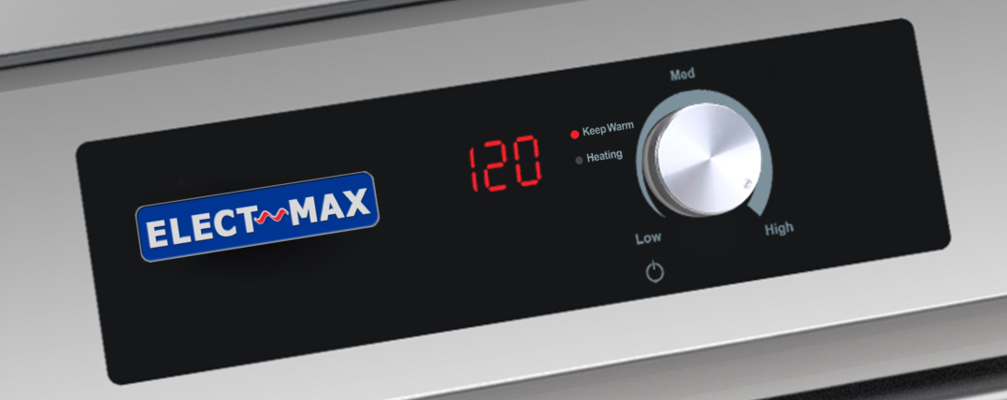
Steps:
1).Turn the Knob to switch on or switch off the equipment, when the GRILL is switched ON, the equipment starts to heat.
2)．Operation：
a．After the GRILL has been switched ON, then the unit starts to work.
b. User can adjust the setting temperature of the GRILL by turning the knob. Setting temperature range is between 80℃and 300℃. Temperature levels is 80℃/100℃/120℃/140℃/160℃/180℃/ 200℃/220℃/240℃/260℃/280℃/ 300 ℃。When the actual temperature of the oil doesn’t reach the setting temperature, the heating light will be ON. When the actual temperature of the oil reaches the setting temperature, then the keep warm light will be ON.

Notes：
●In the use process, the precautions are consistent with the use of open stove.
Special note: This equipment is equipped with an induction coil as an over-temperature protection device. When the temperature of the wire reel reaches 120°C, the system will automatically cut off the working power. At this time, the leakage control switch of this equipment needs to be restarted and the operation is performed again. Steps are fine, but if the temperature of the wire reel has not dropped at this time, it will take a while to restart.
●When the machine fails, the host information display will display the fault code. It should be noted that when the power supply lacks phase or the power connection is poor, the customer can solve it by himself (maintenance personnel must have an electrician certificate). In addition, other failures need to call our company's after-sales service, and the company recommends or dispatches professional maintenance personnel to perform maintenance.

VIII.Error code
If there are any disruptions in the device operation and the display will show an error code check with the table below if the problem can be solved before you contact the customer service or supplier.
ErrorMessage | Cause | Solution
E1 | Temperature of IGBT is too high or temperature testing circuit failure | Clear/unblock ventilation slots.Let the device cool off for a few minutes.the device is ready for the error message remains indicated in the display after the device has cooled off.
E2 | The temperature of grill is too high or temperature sensor under the oil tank is in short-circuit. | Let the device cool off for a few minutes .The device is ready for operation afterwards. Or temperature sensor defective, appliance overheated, let is cool off, contact your supplier if it happens frequently.
E3 | Voltage is unusual | Let the device cool off for a few minutes. The devices is ready for operation afterwards.
E5 | Sensor fault

IX.Storage& Transportation
●It is suitable for general transportation. During transportation, prevent rain and snow from attacking, so as to avoid damage and rust.
●Should be stored in a warehouse where the temperature is -10℃~+40℃, the relative humidity is not more than 80%, and there is no corrosive gas such as acid and alkali.
●The storage period in the packaged state shall not exceed 180 days.
X.Unpacking and inspection
●When unpacking, you should work in a civilized manner, and no rough or barbarous operations are allowed to avoid injury to the equipment in the box or personal injury.
●After unpacking, please first confirm whether this product is the specified product, and then carefully check whether there are any missing parts in the contents of the packing list, and whether there is any damage to the parts due to transportation. If you find any damage, please do so within one week after receiving the product. Contact the company within one week.

