INSTRUCTION MANUAL
Original instructions for
CITRUS JUICER
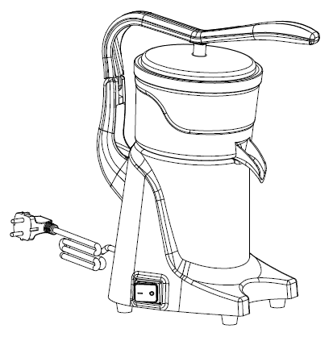
CJ-50MH / CJ-50MC / CJ-50MS

CJ-50MH
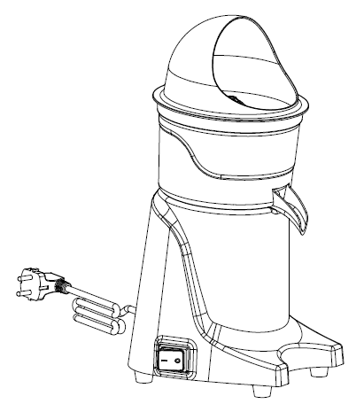
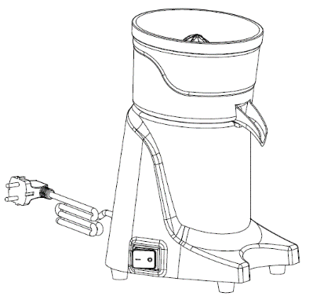

CJ-50MS CJ-50MC

Keep these instructions with the appliance.
You should read this user manual carefully before using the appliance.

Dear Customer,
Thank you for purchasing this appliance. Please take a few minutes before starting operation of the appliance and read the following operating instructions.

- Intended use
  - This machine is designed for commercial used only and must not be used for household.
  - The appliance must only be used for the purpose for which it was intended and designed. Otherwise, it might lead to damage of the machine, property or personal injury.
  - The machine is intended for commercial and indoor use by trained and skilled personnel familiar with these instructions.

The assortment is made up of 3 different models: CJ-50MH / CJ-50MC / CJ-50MS.
The machine body is mainly made in aluminum, stainless steel and ABS for easy cleaning and maintenance. It has safety features compliant with the applicable safety directives.

- Safety regulations 
  - Safety regulations
    - This appliance is intended for commercial use only and must not be used for household use.
    - The appliance must only be used for the purpose for which it was intended and designed. The manufacturer is not liable for any damage caused by incorrect operation and improper use.
    - Keep the appliance and electrical plug away from water and any other liquids. In the event that the appliance should fall into water, immediately remove plug from the socket and do not use until the appliance has been checked by a certified technician. Failure to follow these instructions could cause a risk to lives.
    - Never attempt to open the casing of the appliance yourself.
    - Do not insert any objects in the casing of the appliance.
    - Do not touch the plug with wet or damp hands.
    - Danger of electric shock! Do not attempt to repair the appliance yourself. In case of malfunctions, repairs are to be conducted by qualified personnel only.
    - Never use a damaged appliance! Disconnect the appliance from the electrical outlet and contact the retailer if it is damaged.
    - Do not immerse the electrical parts of the appliance in water or other liquids. Never hold the appliance under running water.
    - Regularly check the power plug and cord for any damage. If the power plug or power cord is damaged, it must be replaced by a service agent or similarly qualified persons in order to avoid danger or injury.
    - Make sure the cord does not come in contact with sharp or hot objects and keep it away from open fire. To pull the plug out of the socket, always pull on the plug and not on the cord.
    - Ensure that the cord (or extension cord) is positioned so that it will not cause a trip hazard.
    - Always keep an eye on the appliance when in use.
    - Warning! As long as the plug is in the socket the appliance is connected to the power source.
    - Turn off the appliance before pulling the plug out of the socket.
    - Never carry the appliance by the cord.
    - Do not use any extra devices that are not supplied along with the appliance.
    - Only connect the appliance to an electrical outlet with the voltage and frequency mentioned on the appliance label.
    - Connect the power plug to an easily accessible electrical outlet so that in case of
emergency the appliance can be unplugged immediately. To completely switch off the appliance pull the power plug out of the electrical outlet.
    - Always turn the appliance off before disconnecting the plug.
    - Never use accessories other than those recommended by the manufacturer. Failure to do so could pose a safety risk to the user and could damage the appliance. Only use original parts and accessories.
    - This appliance is not intended for use by persons (including children) with reduced physical, sensory or mental capabilities, or lack of experience and knowledge.
    - This appliance must not be used by children under any circumstances.
    - Keep the appliance and its cord out of reach of children.
    - Always disconnect the appliance from the mains if it is left unattended or is not in use, and before assembly, disassembly or cleaning.
    - Never leave the appliance unattended during use.

  - Special Safety Regulations
    - The appliance is intended for commercial and indoor use by trained and skilled personnel familiar with these instructions.
    - This machine is designed for citrus juicing in restaurants, canteens and similar catering establishments.
    - Any other use might lead to damage to the appliance or personal injury.
    - Do not place the appliance on a heating object (gasoline, electric, charcoal cooker, etc.) Keep the appliance away from any hot surfaces and open flames. Always operate the appliance on a level, stable, clean, heat-resistant and dry surface.
    - Danger of injury! Care is needed when operating or cleaning.
    - Caution! Securely route the power cord if necessary, in order to prevent unintentional tripping over and falling.
    - Do not use the appliance before it is properly assembled.
    - This appliance is not intended to be operated by means of an external timer or separate emote-control system.
    - Never bypass any safety interlocks on the appliance.
    - WARNING: ALWAYS switch off the appliance and unplug from electrical power supply before cleaning, maintenance or storage.
    - WARNING: ALWAYS keep hands, long hair and clothing away from the moving parts.
    - WARNING: Take great care when appliance running.
    - Allow at least 15cm spacing around the appliance for ventilation purpose during use.
    - Do not wash the appliance with water or waterjet. Washing with water can cause leakage and increase the risk of electric shock. No parts are dishwasher safe.
    - Do not move the appliance while it is under operation. Unplug the appliance when moving and hold it at the bottom.
    - Special care should be taken when moving or transporting the appliance. Move the machine slowly, carefully.
    - This appliance is equipped with a cord having a grounding wire with a grounding plug, the plug must be plugged into an outlet that is properly installed and grounded.

- Product description
3.1 Parts of description

3.2 MAIN TECHNICAL PARAMETERS
CJ-50MH Unit: mm

CJ-50MC Unit: mm

CJ-50MS Unit: mm

MODEL | VOLTAGE | POWER | Speed | N.W. / G.W. | PACKING SIZE
CJ-50MH | 220V-240V~  50/60Hz, 115V~60Hz | 250W | 1500 /min | 8.5/9.8 kgs | 375x255x460 mm
CJ-50MC | 220V-240V~  50/60Hz, 115V~60Hz | 250W | 1500 /min | 6.1/7.5 kgs | 295x255x460 mm
CJ-50MS | 220V-240V~  50/60Hz, 115V~60Hz | 250W | 1500 /min | 6.0/7.0 kgs | 295x255x400 mm
Remark: Technical specification is subjected to change without prior notification.

- Introduction
  - Preparation for first use
    - Check to make sure the appliance is undamaged. In case of any damage, contact your supplier immediately and do NOT use the appliance.
    - Remove all the packing material and protection film (if applicable). Keep the packaging for future storage.
    - Clean the appliance, see: 4.6 Cleaning.
    - Place the appliance on a level and steady surface, unless mentioned otherwise.
    - Make sure there is enough clearance around the appliance for ventilation purposes.
    - Position the appliance in such a way that the plug is accessible at all times.
    - Make sure the power outlet ratings correspond to the specifications printed on the rating plate.
    - Make sure that the machine is connected to a grounding system.
    - Even if safety systems are installed on the machine, prevent approaching moving parts with hands and do not touch the machine with wet or damp hands.
    - It is strongly recommended that the operator contact the after sales center if there is any problem or malfunction occurred. Please do not dismantle the machine or in place of unauthorized parts.

  - The manufacturer will be not responsible for following cases:
    - If the machine is tampered with or safety functions are installed by non-authorized staff.
    - If the components are replaced by unauthorized parts.
    - If the instruction in this manual is not carefully followed.
    - If the machine surfaces are treated with unsuitable substance or solvent.

  - Safety devices
    - Micro-switch: The micro-switch is equipped under the reamer. While apply downward pressure to the reamer, the motor will start automatically. The appliance stops automatically when downward pressure release.
    - Overcurrent protection switch (Circuit breaker): The switch is designed to protect the electrical circuit from damage caused by excess current as a result of an overload or short circuit. The switch interrupts current flow after a fault is detected.

  - INSTALLATION
    - Packing and unpacking
      - Remove all packaging materials. Keep the packaging for future storage.
      - Ensure the packages you received includes following items: citrus juicer machine unit, reamer (CJ-50S and CJ-50C have totally 3 pieces reamers, while CJ-50H has only one), instruction manual.
      - After unpacking all accessories, lay them on a flat and stable surface.
      - Make sure the delivery contents are complete and free of any damage. If you find that parts are missing or show damage, do not use the appliance but contact your dealer.
      - Clean the reamer, strainer, bowl, splash cover, pressing plate and other parts which contact with food.
      - Position the appliance in such a way that the plug is always accessible.

4.4.2 Installation area
The selected machine work setting must be sufficiently lit and have an electric power outlet. The workplace must be sufficiently large, perfectly level and dry. The machine should be installed in non-explosive environments. In any case, installation should be carried out by taking into account any applicable industrial safety regulations in force.

4.4.3 Assembling instructions
Attention: Always unplug the appliance from the electrical power outlet before starting assembling or disassembling.
Place the motor body on a steady and flat table.
- Place the bowl on the motor base. The spout must be in front.
- Place the strainer in the bowl.
- Insert the reamer into the shaft sleeve.
- CJ-50MC only-Place the splash cover onto bowl.

4.4.4 Electric connection
DANGER-CAUTION: Electric connection to the power outlet should be operated by skilled personnel. Check for the perfect efficiency of the plant grounding system. Make sure that the line voltage (V) and frequency (Hz) correspond to the machine ratings (refer to the machine identification plate and wiring diagram). The machine comes equipped with an electric cable with plug. Plug the machine into a main wall switch with differential.

  - OPERATING
    - Preparation
      - Make sure the appliance is unplugged from the electrical power supply, the switch is on “O” position. Check the appliance is properly installed.
      - Prepare fruit in advance by cutting in half. This will make juicing process quicker.
      - Check the strainer and spout are not plugged with pulp or seeds from last use.
      - Place the appliance on a on a horizontal, stable, dry and heat resistant surface with 4 suction cup rubber feet firmly placed on the surface.
      - Place a container underneath the spout to collect the juice.

    - Operating
      - Connect the power plug to a socket outlet.
      - Press down the switch “I” to start.
      - Ream the fruit halves as follows:
        - CJ-50MH
- Place the fruit half over the reamer, and lower the splash cover until the reamer comes in contact with the fruit.
- Apply downward pressure to the splash cover handle. The motor will start automatically.
- Ream the fruit until all the juice is removed, then raise the handle and remove the residues. Repeat the process with the remaining fruit.

        - CJ-50MC and CJ50MS
WARNING: When placing fruit onto the reamer, make sure your hand touches only the fruit and does not come in contact with the reamer.
- Place the fruit half inside the splash cover centered over the reamer and apply downward pressure to force the fruit onto the reamer. The motor will start automatically.
- Ream the fruit until all the juice is removed. Then remove the residues and repeat the process with the remaining fruit.
IMPORTANCE! The amount of juice and percentage of pulp and juice in the juicer depend on variables like temperature, freshness and type of fruit. These variables may result in different outputs which do not depend on the technical features of the juicer unit.
      - When all fruit are reamed, press the switch “O” OFF.
      - In case of any malfunction, defect of the appliance or if you suspect any breakage after a fall, unplug the appliance immediately. If you are unable to solve the problem referring to the table below, contact an Authorized Service Centre. Only qualified technicians should repair the appliance.
We are not liable for any damage caused by repairs not made correctly and/or by unauthorized personnel. In these cases, the warranty does not apply.
Problem | Solution
The appliance does not turn on. | Make sure it is plugged in.
The appliance does not turn on. | Make sure the start button on the appliance is turned ON.
The appliance does not turn on. | If the problem occurs itself after a long time of intensive use or overfilling, the motor could be in thermal protection lock! Wait about 15~20 minutes and try again. The waiting time can be reduced by putting the appliance in a cool place.
Juice will not flow through container spout. | check to see if strainer or spout is plugged with seeds or pulp from the last use.
Juicer will not ream fruit. | Make sure enough pressure is applied to fruit during operation.
Juicer will not ream fruit. | Make sure the reamer is pushed all way down onto the motor shaft.
Juice has bitter taste, rind in juice. | Make sure excessive pressure is not applied to fruit during operation.

  - Cleaning
4.6.1 It is important to keep the appliance clean and in good working condition to ensure optimum quality of the products and long life of the appliance.
4.6.2 Never immerse the appliance in water or other liquids.
4.6.3 To clean the motor housing, unplug the appliance and clean with a damp cloth or sponge with some mild soap solution. Dry with a dry cloth.
4.6.4 Never use abrasive sponges or detergents, steel wool or metal utensils to clean the interior or exterior parts of the appliance.

  - Storage
    - Before reassembling, make sure that all parts are dry. Before storing, remove all residues from the appliance (incl. the basins), disconnect it from the supply and clean the appliance and its accessories thoroughly. Use white Vaseline oil (or any similar product) to protect all parts of the device.
    - To protect the appliance from dust, cover it with a cloth that allows air circulation inside the appliance.

- Circuit diagram

- Exploded view and spare parts lists
CJ-50MH
NO. | Part Name
1 | Handle
2 | Pressing Plate
3 | Reamer
4 | Strainer
5 | Bowl with Spout
6 | Shaft Sleeve
7 | Motor Fixed Plate
8 | Oil Sealing
9 | Housing
10 | Motor
11 | Microswitch fixed plate
12 | Microswitch
13 | Capacitor
14 | Capacitor clamp
15 | Over load protected Switch
16 | Base Plate
17 | Rubber Foot
18 | ON-OFF Switch
19 | Power Cord Clamp
20 | Power Cord
21 | Handle Fixed Part

CJ-50MS/ CJ-50MC
NO. | Part Name
1 | Reamer - Large Size
2 | Reamer - Middle Size
3 | Reamer - Small Size
4 | Strainer
5 | Bowl With Spout
6 | Shaft Sleeve
7 | Motor Fixed Plate
8 | Oil Sealing
9 | Housing
10 | Motor
11 | Microswitch Fixed Plate
12 | Microswitch
13 | Capacitor
14 | Capacitor Clamp
15 | Overload Protected Switch
16 | Base Plate
17 | Rubber Foot
18 | ON-OFF Switch
19 | Power Cord Clamp
20 | Power Cord
21 | Splash Cover (CJ-50MC)

