Shortening Filter
EOF-25
EOF-42
EOF-54

User’s Manual

Firstly, thanks for purchasing and using our product. All the information and guidelines of this user’s manual comply with certain applicable regulations, which come out from our long-term accumulated knowledge and experience as well as current project development situations.
Limited to some special structures, additional specified items or new technology changes, the actual usage situation might be some different from what stated in this user’s manual. Should you have any question, please do not hesitate to contact the manufacturer via the method shown in back cover page of this manual.
For safety purpose and efficient operation, please make this document available to users for reference. Do have them to read this manual carefully before carry out any action on this device, especially when starting.
This manual is not applicable for those who have physical or mental disabilities, insufficient experience, and/or insufficient knowledge, including children.
The manufacturer declines any responsibility in the event users do not follow the instructions or guidelines stated here.
The user’s manual should be placed close to the device, in convenience of users’ reading before operation. We have the full authority to reserve the further technical changes of the device, in the scope of further performance improvement characteristic development.
 Warning
- Any self-modification, wrong installation, adjustment or maintenance can lead to property loss or casualty. Please contact the manufacturer for any adjustment or maintenance, and have the work done by a trained & qualified person.
- For your safety sake, please keep the machine away from any liquid, gas or other object, which is flammable or explosive.
- This appliance should not be operated by those who have physiological, perceptual or mental disabilities or those who have insufficient experience or knowledge (including children). Only in conditions of being given sufficient supervise & guarantee of personal safety, as well as proper instructions & guidance, those who were mentioned above can make some particular operation of this device.
- Keep children away from the device.
- Preserve this manual safely. When passing on/selling the device to a third party, the manuals must be handed over along with the device. All users must operate the device complying with the user’s manual and related safety guidelines.
- Do not store or use gas, liquid or object that is flammable or explosive in the vicinity of the mounting position of the appliance.
- If this appliance is placed near walls, partitions or kitchen furniture and the like, it is advisable to make these facilities with non-combustible material, otherwise cover them with non-combustible heat-resistant material, and pay attention to fire prevention regulations.
Contents

- Functional Introduction…………………………………............…1
- Structure Schematic Diagram & Working Principle…............…1
- Basic Features & Parameters…………………………...........…2
- Precautions & Recommendations …………………….........…..3
- Working Instructions & Operation Flow…………….........…..…5
- Routine Inspection ………………………………..……......…......7
- Cleaning & Maintenance……………………………......…….....7
- Trouble shooting…………………………..........…......…..8

- Functional Introduction
This appliance, which is compact in size and convenient in movement, can remove and clean the fried oil simply and effectively. Filtering the oil with operating temperature by this machine can remove at least 99% impurity and suspended particles in oil effectively to achieve the effects of extending the oil service life and improving the food quality.

Move the filter to position underneath the drain valve of the fryer by pulling the handle. After turning off the heating function of the fryer, open the valve and fill the oil directly into the filtering chamber. After filtering, deliver the oil back to the fryer or other container by the oil hose. We recommend that you have the filtering work done in spare time of afternoon or evening. The oil shall be filtered at least once a day from fresh oil. Only then can it achieve the goal of extending the oil service life.

- Structure Schematic Diagram & Working Principle
  - Structure Schematic Diagram:

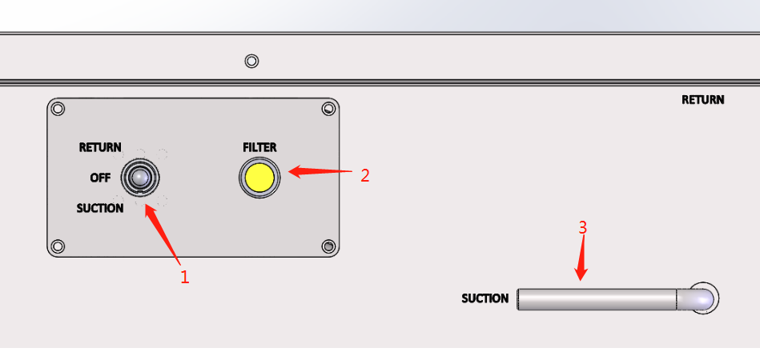

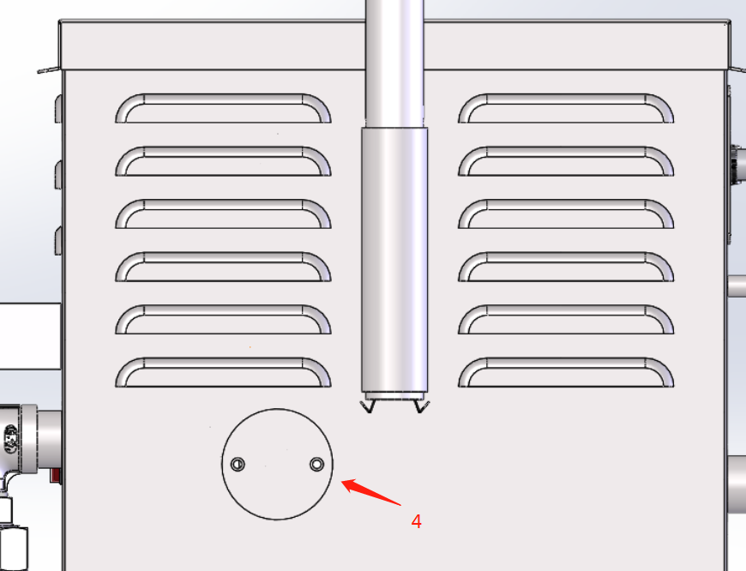

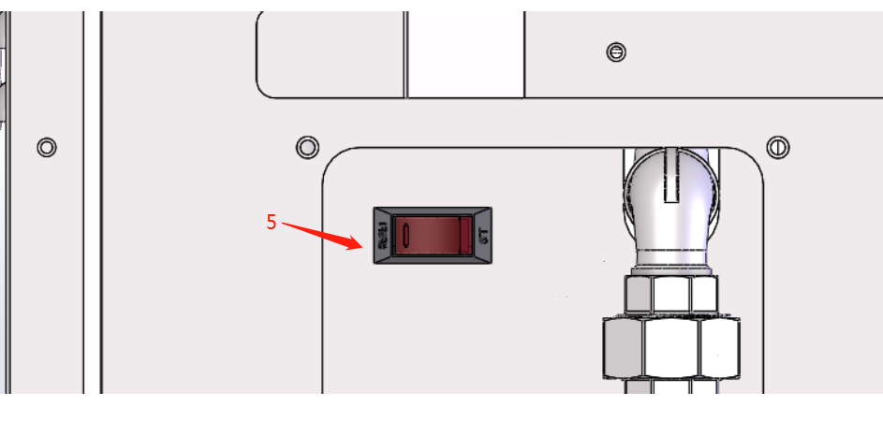

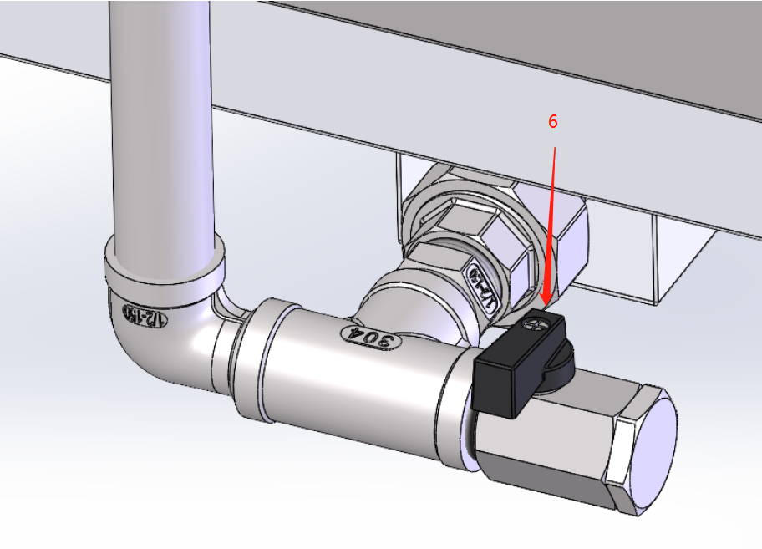

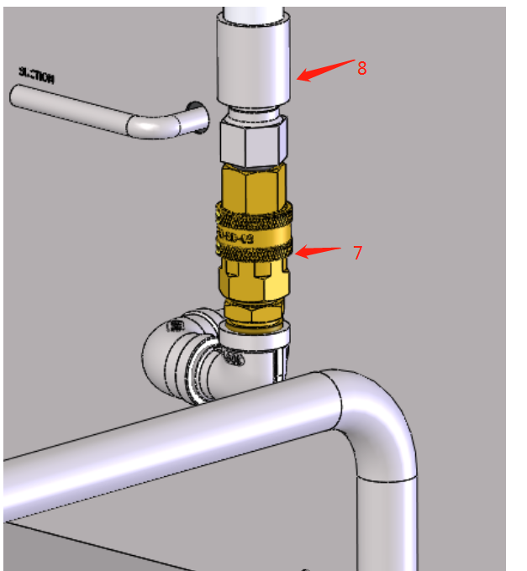
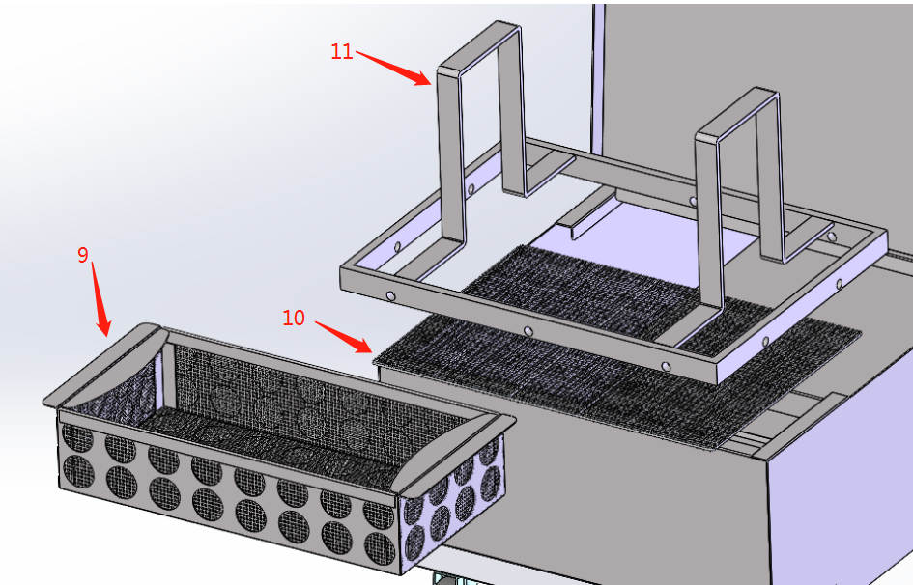
1. Selection switch | 7. Quick disconnect
2. Working indicator | 8. Oil hose
3. Motor rotating direction selecting rod | 9. Pre-filtering basket
4. Motor reset button cover | 10. Filtering mesh net
5. Circuit breaker | 11. Holding ring of filtering paper
6. Drain valve

  - Electrical Diagram:

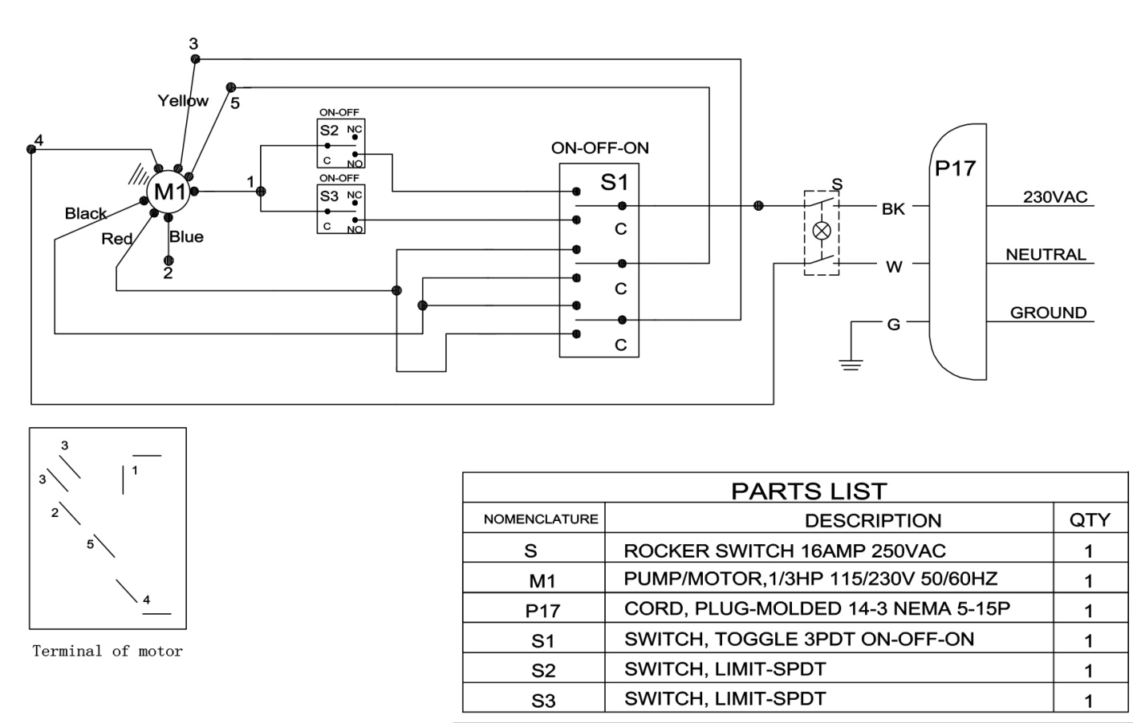
240VAC

- Basic Features & Parameters
Model | EOF-42 | EOF-54
Voltage | 240V, 50Hz | 240V, 50Hz
Power | 250W | 250W
Filtering capacity | 3.5 GPM | 3.5 GPM
Capacity | 85 lbs | 110 lbs
Product diemension | 457 x 727 x 914mm | 505 x 914 x 914mm
Rate of flow(Avg.) | 13L/min | 13L/min
Weight | 51kg | 62kg

- Precautions & Recommendations
  - Transportation and Storage

During transportation, the machine should be carefully handled and do not put it upside down to prevent from damaging to the shell and inside. The packaged machine should be stored in a ventilated warehouse without corrosive gas. If it needs to be stored in open air temporarily, measurement against raining is needed.

  - Notice for Installment

- Do not roll over or over-bend the oil hose.
- To avoid damaging the heating component(s) of the fryer, shut down the heating function of the fryer before starting any filtering operation.
- Cool the oil to 120 ~160℃ before startup for the convenience of operation.
- Pump of this filter is in high precision. Never let dirty oil with solid particle impurity into the pump, neither does hard substance like iron scrap, sand etc..
- After filtering, turn on the drain valve at the back and let the remaining oil be discharged from the pipe to avoid oil freezing and blocking. Otherwise the remaining oil in the pipe may affect the startup next day.
- The pump is very precise, if any failure, please inform our company or send it back immediately for maintenance. Do not dismantle or self-modify it. Self-modification may void the warranty.
- Never pour water in the filter. This may cause rusting of the pipe and pump.
- Carefully lay aside the filtering mesh and filtering layer to avoid deformation caused by crash and ensure the filtering effect.
- The filtering compound should be clear up and replaced daily after use. Carefully deal with the discarded filtering sheet and compound that are flammable.
- Never let the filtering sheet get damp, neither does wash it with water. Generally, to avoid affecting the oil filtering flow, service time of the filtering sheet should not exceed three days.
- To avoid damage of pump, the filter should not run idly for a long period of time after filtering.
- After using, the oil hose must be inserted into the hose slot in filtering chamber.
- Clean up the filter before proceeding filtering.
- Do not immerse the cable/cord into hot oil.
- Do not carry out filtering operation if the oil temperature is higher than 160℃ or lower than 120℃.
- Do not idle the filter for a long period of time.
- Do not wipe the machine with abrasive substance or sandpaper.
- Do not use steel wire brushes!

Warning:
- Caution must be taken during operation. Have the insulation gloves worn during operation due to the high temperature. Do not touch the outer walls of the filtering chamber or oil pipeline. Caution burn!
- During the filtering process, do not move the filter or use the fryer.
- Make sure the oil hose aligns with the fryer tank or oil container during operation. Be cautious of burns caused by hot oil spouted from the oil hose.

- Working Instructions & Operation Flow
- Please check the power cord and plug religiously, making sure that the insulation is in good condition.
- Check all the components carefully for visible damage before initial use. If any, contact the after-sale service department.
- We strongly recommend you to perform filtering on the first day the fresh oil used. Do not have the work done until the oil quality declines.
- Mount the oil hose (8) onto the connector (7).
- Tighten the drain valve (6).

  - Installation Of Filtering Chamber

- Take out all the assembly parts in the filtering chamber and have the filtering paper and compound prepared.
- Put the filtering mesh net(10) in the tank and lay the filtering paper(12) evenly, then put the holding ring(11) on top and make sure no seam is seen.
- Put the pre filtering basket in position.

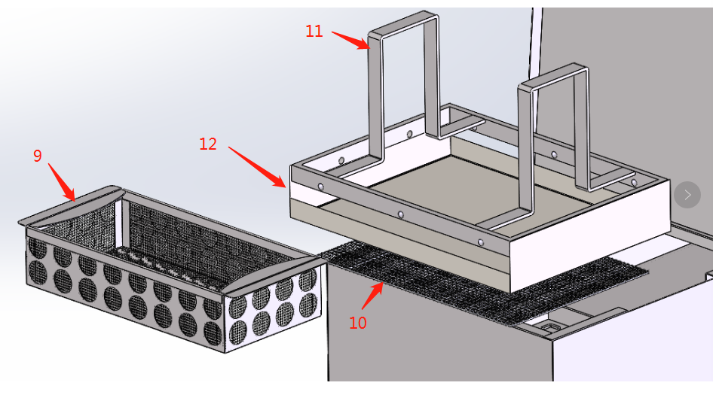

  - Check Before Startup

- If filtering compound is used to do the filtering work, keep the oil temperature between 120~160℃. When filtering powder of Magnesol® XL is used, the oil should reach 140℃.
- To guarantee the optimum filtering effect, please screw the four impaction bolts to compress the rubber gasket tightly.
- Check the drain valve (6) is tightened to avoid leakage.
- Check the power voltage of the working environment complies with the requirement of this manual.

Warning Do not direct the nozzle of the oil hose to the operator or the person present. Hot oil may cause severe injury.

  - Start Or Stop Filtering

Return

- Drain the oil in the filter tank. Shut off the drain valve. Point the oil hose to the fryer tank.
- Rotate the motor direction selecting rod(3) to RETURN position.
- Turn the main switch to RETURN. The filtering pump would work. Inspect the oil visually, when it is sucked up, press the button switch again. At this time, the indicator will go off and the filter stops working.
- If the filter needs to be stopped during the filtering process, turn off the main switch.
Vacuum
This filter also has a vacuum function.
The operation procedure is as below:
Put the filtering paper and holding ring well. Point the oil hose to the fryer tank and immerse the oil hose in the oil. Rotate the motor direction rod to SUCTION. Then rotate the main switch to SUCTION.

  - Filtering Time

It is advisable to cycle the filtering for 15min, then fill all the oil back into the fryer tank or container.
! The filter shall be supervised by operator during the cycling. If the oil level rises in the chamber, stop filling.

  - Automatic Protection & Overload Protector

If the oil hose is blocked or the pump is seized, the overload protector (3) will disconnect and the appliance will shut down automatically to protect the motor from overburning caused by excessive current. If the filter stops automatically during operation, check that whether the oil hose is blocked or the pump is seized by foreign matter.

Find out fault:
- If the oil hose is blocked due to oil solidification, pour some hot oil into the chamber to immerse for a while to melt the concretionary residual oil.
- If the external oil hose is blocked by residual oil, immerse the hose into hot water till the residual oil is melted then connect it back to the appliance.
If the fault is found, press the overload protector (3) button then start up the appliance.

If the appliance cannot work normally after following the aforementioned operations, or the failure occurs in first startup after purchase, please contact and consult the distributor or after-sale service department.

- Routine Inspection
It is necessary to check the machine daily.
Check the machine regularly can avoid serious accident happens.
Stop using if user feels that there are some problems in the circuit or machine.
Check the situation of the machine before or after using every day.

Before using: Whether the machine is tilted?
Whether the control panel is damaged?
Whether the power cord is aging, cracking or damaged?

During using: Whether there is strange odor or vibration noise?
Whether the power is normal?

Replace The Filtering Sheet

Warning Do not substitute the filtering sheet before cooling down.

! If the appliance is not used for a long period of time, the filtering sheet must be replaced. (For example) After holidays or be in an interval of 1 day.

The filtering sheet shall be substituted depending on actual situation. Regular substitution can improve the filtering effect or efficiency and reduce the wear and tear of the appliance. The substitution frequency depends on the filtering frequency or times and the oil cleanness. We suggest that the filtering sheet shall be replaced when it is blocked or the oil outlet drains slowly during the filtering process. Daily substitution may guarantee the food safety and product taste better.

If too many dregs are found but the filtering sheet is not blocked, remove and clean it promptly. Scrape the dregs and filtering compound with a clean slab rubber, then replace the compound to continue filtering.

- Cleaning & Maintenance
- Disconnect the power, insert the straight pipe part of the oil hose into the hose slot (9), which can not only keep the hose clean, but collect the oil drip.
- Cool it down, then take out all components in the filtering layer. Discard the filtering sheet and compound used, and clean up the filtering chamber.
- Open the drain valve (6) to discharge the residual oil in the oil hose and pump, preventing the residual oil from cooling solidification which may affect the re-startup.

- Trouble Shooting

Symptoms | Causes | Solutions
Press the button, the indicator is not on and the motor cannot start/activate. | - Power is disconnected.  - The breaker is not switched on.  - Overload protection caused by pump seizing.  - The reset switch disconnects due to overheat. | - Connect the power.  - Switch on the breaker.  - Cool down and press the reset switch.  - Clean the pipeline and press the reset switch.
Press the button, the indicator illuminates, but the motor does not work. | - The motor is defective. | 1. Repair the motor.
It cannot drain or drains little. | - The filtering layer is blocked.  - The oil hose leaks.  - The pump is worn. | - Replace the filtering sheet and compound.  - Reset the oil hose.  - Replace the pump or relevant parts.

Aforementioned troubles are just for reference. If any failure occurs, please stop using and inform the professional technicians to check and repair.


