SPIRAL MIXERS

OPERATION INSTRUCTION

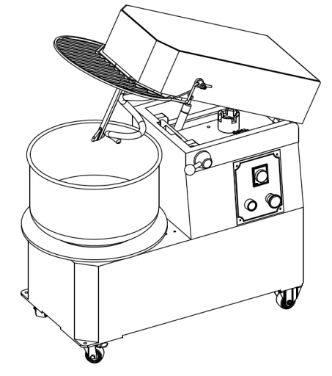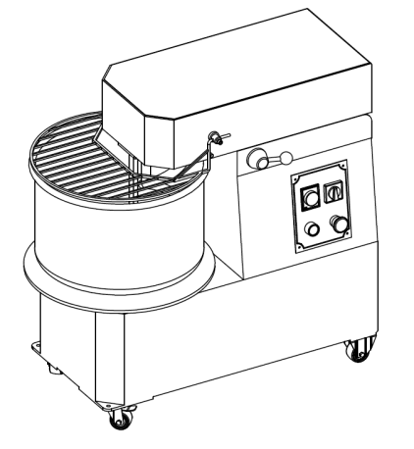
HTD –B SERIES DOUBLE SPEED RISED HEAD SPIRAL MIXER
HTD SERIES SINGLE SPEED RISED HEAD SPIRAL MIXER

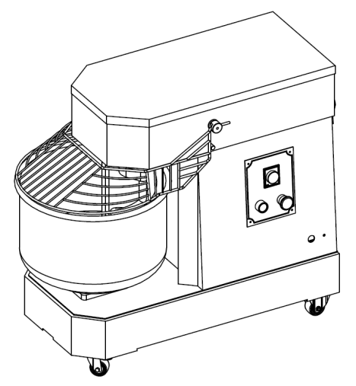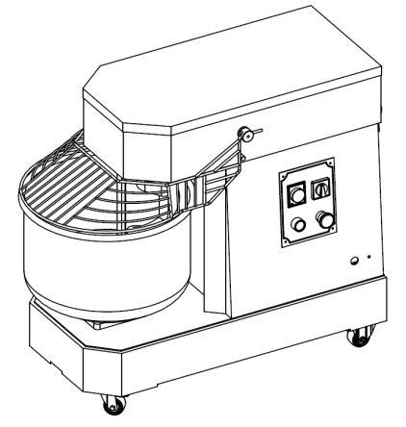
DN-B SERIES DOUBLE SPEED FIXED HEAD SPIRAL MIXER
DN SERIES SINGLE SPEED FIXED HEAD SPIRAL MIXER

- PLEASE READ INSTRUCTION THROUGHTLY BEFORE USING THE EQUIPMENT

Content
CHAPTER 1 COMPANY BRIEF INTRODUCTION ………………………...…..P₁
CHAPTER 2 PRODUCTION INTRODUCTION…………………………...…..P₂
2.1 Machine trait ……………………..…………………………….………....…..P2-3
2.2 Technical parameter ………………………..………………..………......P4-6
CHAPTER 3 HOW TO INSTALL AND USE THE MIXER….……………..…...P7
3.1 Safety Precautions…………………………………..………………………….P7
3.2 How to clean? …..........................................................................................P7
3.3 How to remove the bowl from rised head removable bowl spiral mixer ?.....….P7
3.4 How to use the Mixer ?.………………………………….………………….....P8
CHAPTER 4 MAINTENANCE……………………………………………….....…P9
4.1 Maintenance………………………………...……………………….………….P₉
4.2 Problem Solving …………………………………………….………………….P₉
CHAPTER5 EXPOLSIVE VIEW AND PARTS LIST…………………..……..…P10
5.1 Electrical wiring diagram …………………………………..….…….…………….P₁₁-P₁₅
5.2 Transformer……………………………………...……………………………….P₁₆
5.3 Explosive view and Part list……………………………………..…….….………..P₁₇-P₂₁
WARRANTY CARD.…................................................................................................P₂₂

CHAPTER 1 COMPANY BRIEF INTRODUCTION
Thanks for choosing our machines, we are a company who specialized in food processing machines field for many years, the main products are spiral mixer, meat grinder/mincer,meat slicer, sausage stuffer/filler and so on .
with the strength of good quality and After-sales service ,we won reputation from the customers all around the world

TECHNICAL PARAMETER SUBJECT TO CHANGE WITHOUT NOTICE
1
CHAPTER 2 PRODUCTION INTRODUCTION
We have the perfect Spiral mixers which come in compact design constrcution ,the size from 5 liter volumn that is both attractive and powerful, to the commercail 60liter volumn ,suit different customers needs (especially for bakery shops restaurants use,..)
1. 1MIXER TRAIT
1) All parts that contact food directly are made of stainless steel
2) Powerful motor ,and it is equipped with cooling fans
3) Single speed or double speed selction suit different needs
4) Most of mixer is equipped with Timer and castor with stopper.
5) CE approved .
Improper usage of this equipment can result in and damage. Please read the instruction throughly before using the equipments for safety Please keep this manual for future reference

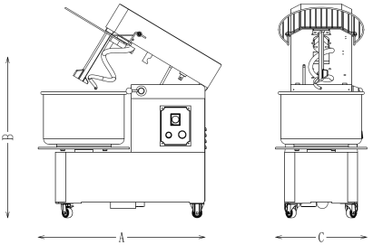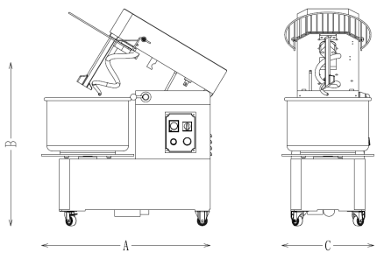
HTD and HTD-B series Rised head and removable bow spiral mixer (single speed and double speed )

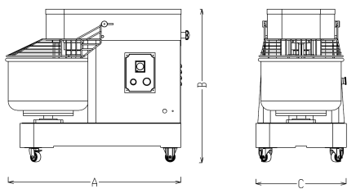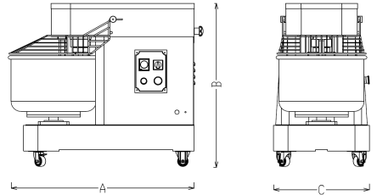
DN and DN-B series Fixed head and Fixed bow spiral mixer (single speed and double speed )

TECHNICAL PARAMETER SUBJECT TO CHANGE WITHOUT NOTICE
2
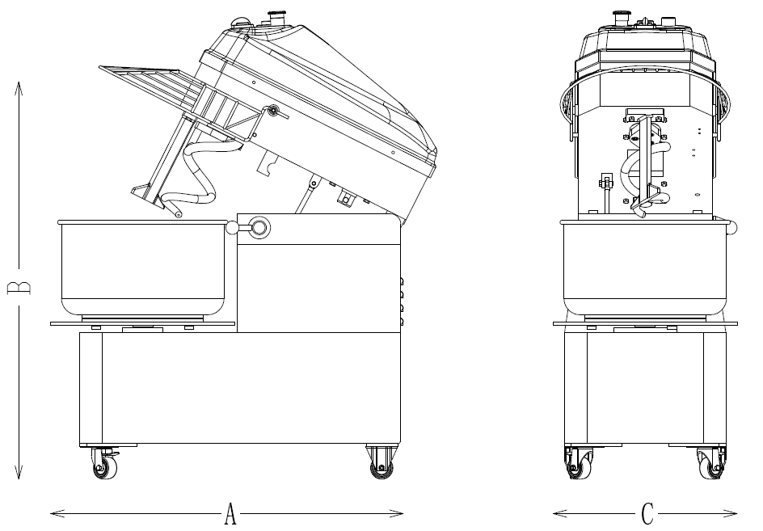

DT SINGLE SPEED FIXED HEAD FIXED BOWL SPIRAL MIXER DT B DOUBLE SPEED FIXED HEAD FIXED BOWL SPIRAL MIXER

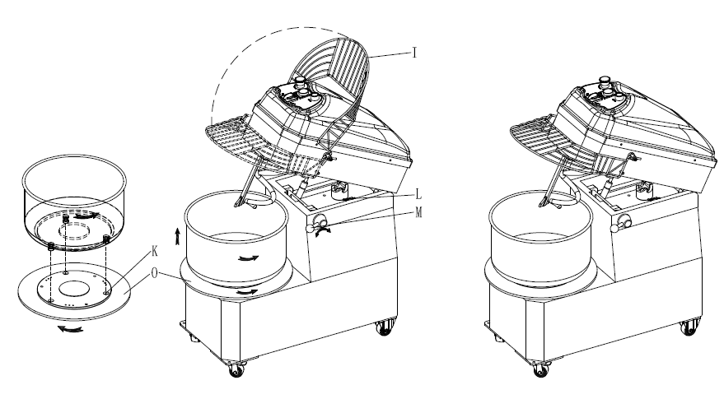
HTT SINGLE SPEED RISED HEAD FIXED BOWL SPIRAL MIXER HTT B DOUBLE SPEED RISED HEAD FIXED BOWL SPIRAL MIXER

TECHNICAL PARAMETER SUBJECT TO CHANGE WITHOUT NOTICE
3
2.1 TECHNICAL PARAMETER
2.1.1 Rised Head And removable Bowl Spiral Mixer Technical parameter (HTD SERIERS HTD-B SERIES Spiral mixer with Flat metal top cover)
2.1.2 Rised Head And Fixed Bowl Spiral Mixer Technical parameter (HTT SERIERS HTT-B SERIES Spiral mixer with,Blue plastic top cover )
2.1.3 Rised Head single speed spiral mixer
Model | Bowel volume  (L) | Bowl  Size  (mm) | Max Dry Flour Capacity  (Kg) | Max Dough  Capacity  (Kg) | Rotation speed  Bowl/hook  (R.P.M.) | Rated power  (KW) | Power  supply |  | G.W/N.W  (Kg) | Machine Size  (A*B*C)  (mm)
HTD10 | 10 | φ300x210 | 4 | 6 | 16/156 | 0.4 | □110V/60Hz/1Ph;  □220-240V/50Hz/1Ph |  | 85/71 | 730*300*635
HTD20  HTT20 | 20 | φ360x210 | 8 | 12 | 16/156 | 1.5 | □110V/60Hz/1Ph;  □220-240V/50Hz/1Ph□220V/60Hz/3Ph  □380V/50HZ/3Ph  □415V/50HZ/3Ph |  | 150/134 | 750*400*730  750*400*870
HTD30  HTT30 | 30 | φ380x260 | 12 | 18 | 16/156 | 1.5 | □110V/60Hz/1Ph;  □220-240V/50Hz/1Ph  □220V/60Hz/3Ph  □380V/50HZ/3Ph  □415V/50HZ/3Ph |  | 160/142 | 790*430*830  790*430*980
HTD40  HTT40 | 40 | φ450x270 | 16 | 24 | 16/156 | 2.2 | □110V/60Hz/1Ph;  □220-240V/50Hz/1Ph  □220V/60Hz/3Ph  □380V/50HZ/3Ph  □415V/50HZ/3Ph |  | 202/173 | 860*480*930  860*480*1080
HTD50  HTT50 | 50 | φ500x270 | 20 | 30 | 16/156 | 2.2 | □220V/60Hz/3Ph  □380V/50HZ/3Ph  □415V/50HZ/3Ph |  | 205/176 | 860*500*930  860*500*1080
2.1.4 Rised head double speed Spiral mixer
HTD10B | 10 | φ300x210 | 4 | 6 | 16/156  11/103 | 0.7/0.35 | □220V/60Hz/3Phs  □380V/50HZ/3Phs  □415V/50HZ/3Phs | 85/71 |  | 730*300*635
HTD20B  HTT20B | 20 | φ360x210 | 8 | 12 | 16/156  11/103 | 1.5/1.1 | □220V/60Hz/3Phs  □380V/50HZ/3Phs  □415V/50HZ/3Phs | 150/134 |  | 750*400*730  750*400*870
HTD30B  HTT30B | 30 | φ380x260 | 12 | 18 | 16/156  11/103 | 1.5/1.1 | □220V/60Hz/3Phs  □380V/50HZ/3Phs  □415V/50HZ/3Phs | 160/142 |  | 790*430*830  790*430*980
HTD40B  HTT40B | 40 | φ450x270 | 16 | 24 | 16/156  11/103 | 2.2/1.5 | □220V/60Hz/3Phs  □380V/50HZ/3Phs  □415V/50HZ/3Phs | 202/173 |  | 860*480*930  860*480*1080
HTD50B  HTT50B | 50 | φ500x270 | 20 | 30 | 16/156  11/103 | 2.2/1.5 | □220V/60Hz/3Phs  □380V/50HZ/3Phs  □415V/50HZ/3Phs | 205/176 |  | 860*500*930  860*500*1080

TECHNICAL PARAMETER SUBJECT TO CHANGE WITHOUT NOTICE
4
2.2.1 FIXED Head And FIXED Bowl Spiral Mixer Technical parameter ( DN SERIERS DN-B SERIES SPIRAL MIXER with Flat metal top cover
2.2.2 FIXED Head And Fixed Bowl Spiral Mixer Technical parameter (DT SERIERS AND DT-B SERIES SPIRAL MIXER with Blue plastic top cover )

2.2.3 DN and DT Series Single Speed Spiral Mixer technical parameter

Model | Bowel volume  (L) | Bowl  Size  (mm) | Max Dry Flour Capacity  (Kg) | Max Dough  Capacity  (Kg) | Rotation  speed  Bowl/hook  (R.P.M.) | Rated power  (KW) | Power  supply | G.W/N.W  (Kg) | Machine Size  (A*B*C)  (mm)
DN5 | 5 | φ210x160 | 2 | 3 | 19/193 | 0.2 | □110V/60Hz/1Ph;  □220-240V/50Hz/1Ph | 35/30 | 560*230*480
DN10 | 10 | φ300x210 | 4 | 6 | 19/193 | 0.4 | □110V/60Hz/1Ph;  □220-240V/50Hz/1Ph | 82/70 | 730*300*635
DN15 | 15 | φ320x210 | 6 | 9 | 19/193 | 1.1 | □110V/60Hz/1Ph;  □220-240V/50Hz/1Ph | 135/113 | 840*390*720
DN20  DT20 | 20 | φ360x210 | 8 | 12 | 19/193 | 1.5 | □110V/60Hz/1Ph;  □220-240V/50Hz/1Ph | 142/124 | 840*420*720  840*420*900
DN30  DT30 | 30 | φ380x260 | 12 | 18 | 19/193 | 1.5 | □110V/60Hz/1Ph;  □220-240V/50Hz/1Ph  □220V/60Hz/3Phs  □380V/50HZ/3Phs  □415V/50HZ/3Phs | 149/129 | 870*450*840  870*450*1020
DN40  DT40 | 40 | φ450x270 | 16 | 24 | 19/193 | 2.2 | □110V/60Hz/1Ph;  □220-240V/50Hz/1Ph  □220V/60Hz/3Phs  □380V/50HZ/3Phs  □415V/50HZ/3Phs | 202/173 | 1000*510*920  1000*510*1110
DN50  DT50 | 50 | φ500x270 | 20 | 30 | 19/193 | 2.2 | □220V/60Hz/3Phs  □380V/50HZ/3Phs  □415V/50HZ/3Phs | 208/177 | 1003*530*920  1003*530*1110
DN60 | 60 | φ540x270 | 25 | 37.5 | 18/178 | 3.0 | □220V/60Hz/3Phs  □380V/50HZ/3Phs  □415V/50HZ/3Phs
DN80 | 80 | φ600*270 | 30 | 45 | 18/178 |  | □220V/60Hz/3Phs  □380V/50HZ/3Phs  □415V/50HZ/3Phs
DN100 | 100 | φ600x360 | 40 | 60 | 16/210 |  | □220V/60Hz/3Phs  □380V/50HZ/3Phs  □415V/50HZ/3Phs
DN130 | 130 | φ700x360 | 50 | 75 | 16/210 |  | □220V/60Hz/3Phs  □380V/50HZ/3Phs  □415V/50HZ/3Phs
DN200 | 200 | φ795x410 | 75 | 112 | 16/200 |  | □220V/60Hz/3Phs  □380V/50HZ/3Phs  □415V/50HZ/3Phs
DN260 | 260 | φ900x410 | 100 | 150 | 16/200 |  | □220V/60Hz/3Phs  □380V/50HZ/3Phs  □415V/50HZ/3Phs

TECHNICAL PARAMETER SUBJECT TO CHANGE WITHOUT NOTICE
5
2.2 DN-B and DT-B Series Double Speed Spiral Mixer technical parameter
Model | Bowel volume  (L) | Bowl  Size  (mm) | Max Dry Flour Capacity  (Kg) | Max Dough  Capacity  (Kg) | Rotation speed  Bowl/hook  (R.P.M.) | Rated power  (KW) | Power  supply | Weight  (Kg) | Machine Size  (A*B*C)  (mm)
DN10B | 10 | Φ300x210 | 4 | 6 | 19/193  13/132 | 0.6/0.4 | □220V/60Hz/3Ph  □380V/50HZ/3Phs  □415V/50HZ/3Phs | 82/70 | 730*300*635
DN15B | 15 | φ320x210 | 6 | 9 | 26/178  18/120 | 1.1/0.8 | □220V/60Hz/3Ph  □380V/50HZ/3Phs  □415V/50HZ/3Phs | 135/113 | 840*390*720
DN20B  DT20B | 20 | φ360x210 | 8 | 12 | 19/193  13/132 | 1.5/1.1 | □220V/60Hz/3Ph  □380V/50HZ/3Phs  □415V/50HZ/3Phs | 142/124 | 840*420*720  840*420*900
DN30B  DT30B | 30 | φ380x260 | 12 | 18 | 19/193  13/132 | 1.5/1.1 | □220V/60Hz/3Ph  □380V/50HZ/3Phs  □415V/50HZ/3Phs | 149/129 | 870*450*840  870*450*1020
DN40B  DT40B | 40 | φ450x270 | 16 | 24 | 19/193  13/132 | 2.2/1.5 | □220V/60Hz/3Ph  □380V/50HZ/3Phs  □415V/50HZ/3Phs | 202/173 | 1000*510*920  1000*510*1110
DN50B  DT50B | 50 | φ500x270 | 20 | 30 | 19/193  13/132 | 2.2/1.5 | □220V/60Hz/3Ph  □380V/50HZ/3Phs  □415V/50HZ/3Phs | 208/177 | 1003*530*920  1003*530*1110
DN60B | 50 | φ540x270 | 25 | 37.5 | 18/178  12/118 | 3.0/2.4 | □220V/60Hz/3Ph  □380V/50HZ/3Phs  □415V/50HZ/3Phs
DN80B | 50 | Φ600x270 | 30 | 45 | 18/178  12/118 |  | □220V/60Hz/3Ph  □380V/50HZ/3Phs  □415V/50HZ/3Phs
DN100B | 50 | φ600x360 | 40 | 60 | 26/178 |  | □220V/60Hz/3Ph  □380V/50HZ/3Phs  □415V/50HZ/3Phs
DN130B | 50 | φ700x360 | 50 | 75 | 26/178 |  | □220V/60Hz/3Ph  □380V/50HZ/3Phs  □415V/50HZ/3Phs
DN200B | 50 | φ795x410 | 75 | 112 | 26/178 |  | □220V/60Hz/3Ph  □380V/50HZ/3Phs  □415V/50HZ/3Phs
DN260B | 50 | φ900x410 | 100 | 150 | 26/178 |  | □220V/60Hz/3Ph  □380V/50HZ/3Phs  □415V/50HZ/3Phs

TECHNICAL PARAMETER SUBJECT TO CHANGE WITHOUT NOTICE
6
CHAPTER 3 HOW TO USE THE MIXER?
3.1Safety Precautions
Improper usage of this equipment can result in damage. Please read the instruction throughly before using the equipments for safety Please keep this manual for future reference
1) keep children away from the machine
2) The user must set time first before starting the machine , if the timer stays at Zero position ,the bowl of mixer will not spinning and the the body of mixer will vibration when push start button, it is not allowed to start machine without set mixing time
3) IMPORTANTANCE : Make sure bowl spinning direction is same as the mark (as picture shown ) , If the bowl spins oppositely , the user may got wrong wire connection ,this is A wrong operation
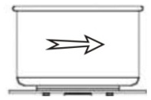
4) The mains plug and the mains cable should be inspected for damage. Never operate the mixer if the plug or cable is damaged
5) This mixer should only be connected to the right power sources.
6) The machine should be placed as picture shown in order to heat dissipation .
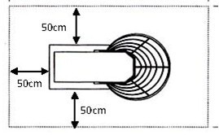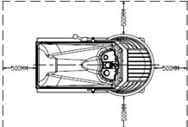
7) Put the machine well ,Fixed it by pressing down the stopper that on casters , and have the support feet on for STEADY
(4 support feet supplied )
8) The Mixer must be mounted on a plain, horizontal, non slip Surface, Remember that the machine is very heavy ,always move it with care
9) You should clean the bowl when you first use it and also at the start of every day. This is important because it ensures the parts in contact with the Food are hygienically clean – Remember to unplug the machine every time when cleaning
The mains socket should be within easy reach of the operator for quick disconnection in case of emergency or when cleaning

10) NO WET HAND OPERATION ALLOWED
11) It is not recommended let the machine overload working, please view technical parameter for more details
12) Always keep working area clean and dry

TECHNICAL PARAMETER SUBJECT TO CHANGE WITHOUT NOTICE
7
3.4 HOW TO USE THE MIXER?
There are these buttons on the electric control panel ,please see below pictures

Single speed spiral mixer Electrical control plate Double speed spiral mixer Electrical control plate
1,The Timer （To set mixing time from 0-30 minutes , the mixer will stop working automatically when it reaches to stipulated time
2 ,Start putton ( the Green one ) ,push the button ,the mixer starts to work
3, Emergency stop switch (the Red one ),push the button , the mixer stop working immediately
4 ,Fast speed and slow speed change-over switch （the Black one）,you can choose the speed switch to let the machine working in fast or slow . THIS SWITCH IS ONLY FOR DOUBLE SPEED SPIRAL MIXER

OPERATION
Put water and flour into the bowl ,set time ,put down safety guard (lid) ,choose fast or slow speed( the black one ) to let the machine work in fast or slow
,push start botton (the green one ) , the mixer starts to work you will have right dough few minutes later
After finished clean the machine
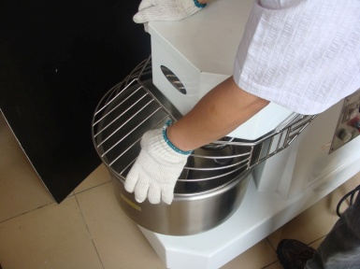
Although plug in, the Mixer will not start to work if the (safety guard ) lid is not put down, you must put the lid down before starting,

TECHNICAL PARAMETER SUBJECT TO CHANGE WITHOUT NOTICE
8
CHAPTER 4 MAINTENANCE AND STORAGE
4.1 MAINTENANCE
1) Strictly according to the instructions to operate the equipment, will greatly prolong its service life
THE MANUFACTURER SHOULD NOT BE RESPONSIBLE FOR THE DAMAGE WHICH CAUSED BY IMPROPER OPERATION
2) It is recommended to check the belt and drive chain every 3 months, if they are too loose ,,adjust them properly by adjusting upper tension gear or replace them . Add some lubricating oil on. (case- by case basis)
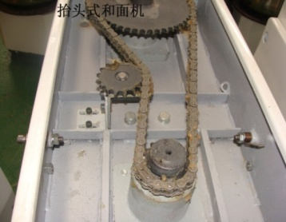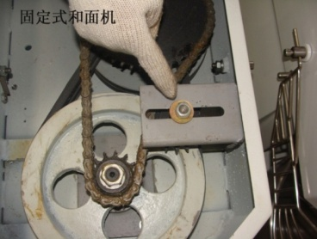
Upper Tension gear of Rising head spiral mixer Upper Tension gear of Fixed head spiral mixer
3) THIS EQUIPMENT SHOULD BE STORED IN CLEAN AND DRY AREA DO NOT EXPOSE THIS EQUIPMENT TO RAIN OR MOISTURE
4.2 PROBLEMS SOLVING
The user might encounter below situations
PROBLEM | CHECK | SOLUTION
The mixer will not working | Socket NO electric supply | Supply electric power on
The mixer will not working | Emergency switch (the red one ) locked | Unlock emergency switch  As Arrow direction shows
The mixer will not working, but stuttering | Timer stands on 0 position | Turning timers of 1 to 60 mins
The mixer will not working | The head of mixer is lifted | Press down the head of mixer and locked it well
The mixer will not working | Safety guard (lid)is lifted | Put the safety guard (lid) down the bowl .
The head of mixer can not be press down | The drive couplings not in alignment | Turn the hook in order to let the drive coupling match well
The mixer will not working | 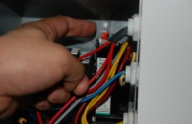  The Overload Relay  (JR) shut off | Press down the red reset button
The hook stuttering is when in use | The belt or drive chain too loose  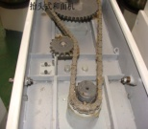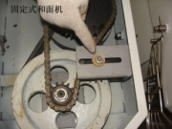 | Adjust the belt or drive chain  (by adjusting the tension gear to tighten the belt or drive chain )  OR Replace belt or drive chain
The bowl jumping and stuttering when in use | The belt or drive chain too loose | Adjust the belt or drive chain  (by adjusting the tension gear to tighten the belt or drive chain )  OR Replace belt or drive chain
The bowl jumping and stuttering or come loose when in use | The screws under bowl locking plates are too loose | Tighten these screws .

TECHNICAL PARAMETER SUBJECT TO CHANGE WITHOUT NOTICE
9
CHAPTER 5 EXPLORE VIEW AND SPARE PARTS LIST
5.1 Electrical wiring diagram
5.1.1 Single phase Single speed Rising head Spiral mixer Electrical wiring diagram 220V/50HZ Or 110V/60HZ (HTD-10 to 50 and HTT-10 to 50series)
Annotations
CJ------ AC Contactor
JS---- Time relay
JR--- Overload Relay
AL₀---- Emergency switch
AL₁----- Start button
LX₁ LX₂------ Micro Switch
--------- Time relay contact point
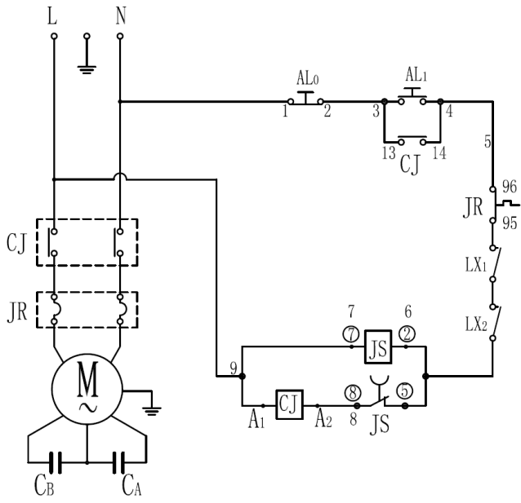
5.1.2 Single phase Single speed Rising head Spiral mixer Electrical wiring diagram
(equipped with transformer ，transformer optional ) 220V/50HZ or 110V/60HZ, 24 Voltage control panel
For HTD-10 to 50 and HTT-10 to 50series
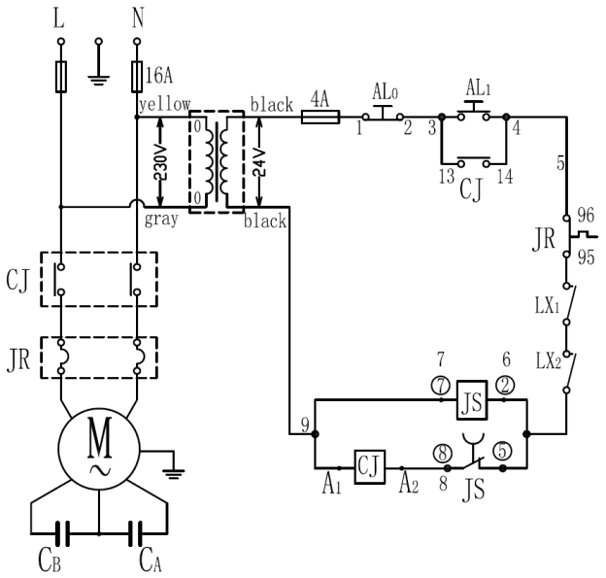
Annotations
CJ------ AC Contactor
JS---- Time relay
JR--- Overload Relay
AL₀---- Emergency switch
AL₁----- Start button
LX₁ LX₂------ Micro Switch
--------- Time relay contact point
TECHNICAL PARAMETER SUBJECT TO CHANGE WITHOUT NOTICE
10
5.1.3 Three phases Double speed Rising head Spiral mixer Electrical wiring diagram 380(415)V/50HZ or 220V/60HZ For DN10 to DN60 Series and DT10 to DT60 series
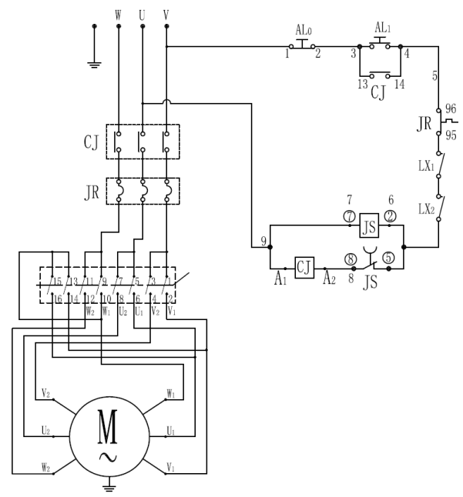
Annotations
CJ------ AC Contactor
JS---- Time relay
JR--- Overload Relay
AL₀---- Emergency switch
AL₁----- Start button
LX₁ LX₂------ Micro Switch
--------- Time relay contact point
5.1.4 Three phases Double speed Rising head Spiral mixer Electrical wiring diagram
( Equip with transformer, transformer optional ) 380V/50Hz or 220/60Hz, 24V control
For HTD-10B to 50B series and HTT-10B to HTT-50B series
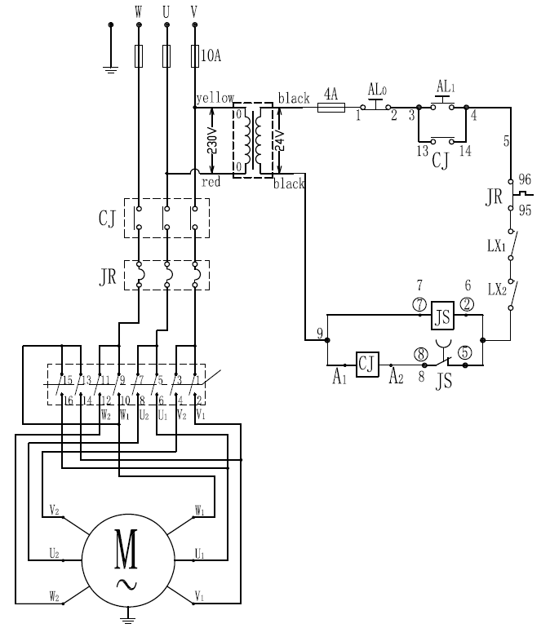
Annotations
CJ------ AC Contactor
JS---- Time relay
JR--- Overload Relay
AL₀---- Emergency switch
AL₁----- Start button
LX₁ LX₂------ Micro Switch
--------- Time relay contact point
TECHNICAL PARAMETER SUBJECT TO CHANGE WITHOUT NOTICE
11
5.1.5 Single phase Single speed Fixed head Spiral mixer Electrical wiring diagram 220V/50Hz or 110V/60Hz
Annotations
CJ------ AC Contactor
JS---- Time relay
JR--- Overload Relay
AL₀---- Emergency switch
AL₁----- Start button
LX₁ LX₂------ Micro Switch
--------- Time relay contact point
For DN10 to DN60 Series and DT10 to DT60 series
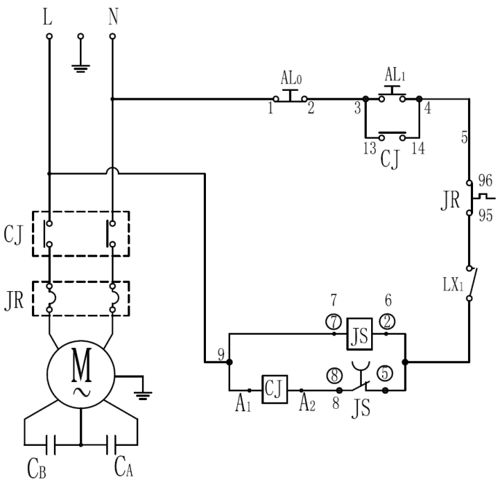
5.1.6 Single phases Single speed Fixed head Spiral mixer Electrical wiring diagram
(Equipped with transformer，transformer optional, ) 220V/50Hz or 110V/60Hz 24V control panel
For For DN10 to DN60 Series and DT10 to DT60 series
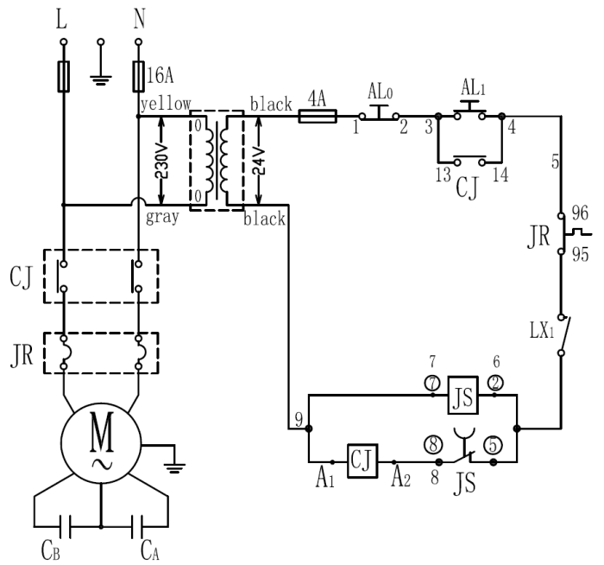
Annotations
CJ------ AC Contactor
JS---- Time relay
JR--- Overload Relay
AL₀---- Emergency switch
AL₁----- Start button
LX₁ LX₂------ Micro Switch
--------- Time relay contact point

TECHNICAL PARAMETER SUBJECT TO CHANGE WITHOUT NOTICE
12
5.1.7 Three phases Double speed Fixed head spiral mixer Electrical wiring diagram 380V/50Hz or 220V/60Hz For DN10B to DN60B Series and DT10B to DT60B series
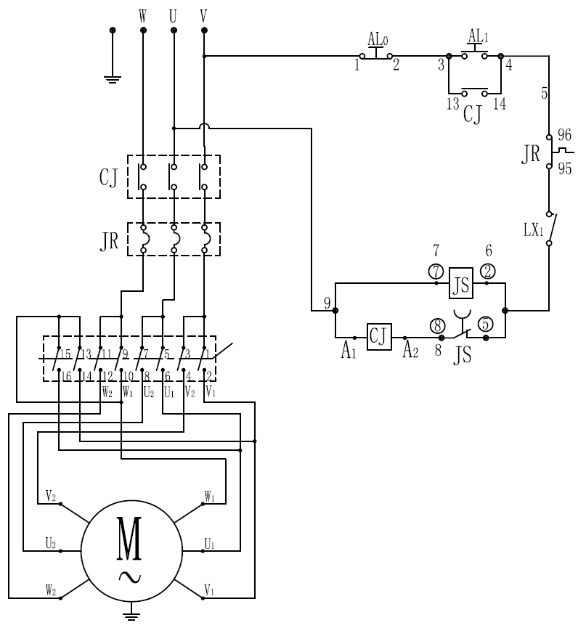
Annotations
CJ------ AC Contactor
JS---- Time relay
JR--- Overload Relay
AL₀---- Emergency switch
AL₁----- Start button
LX₁ LX₂------ Micro Switch
--------- Time relay contact point
5.1.8 Three phases Double speed Fixed head spiral mixer Electrical wiring diagram (equipped with transformer，transformer optional ) 380V/50Hz or 220V/60Hz 24V control panel
For DN10B to DN60B Series and DT10B to DT60B series
Annotations
CJ------ AC Contactor
JS---- Time relay
JR--- Overload Relay
AL₀---- Emergency switch
AL₁----- Start button
LX₁ LX₂------ Micro Switch
--------- Time relay contact point
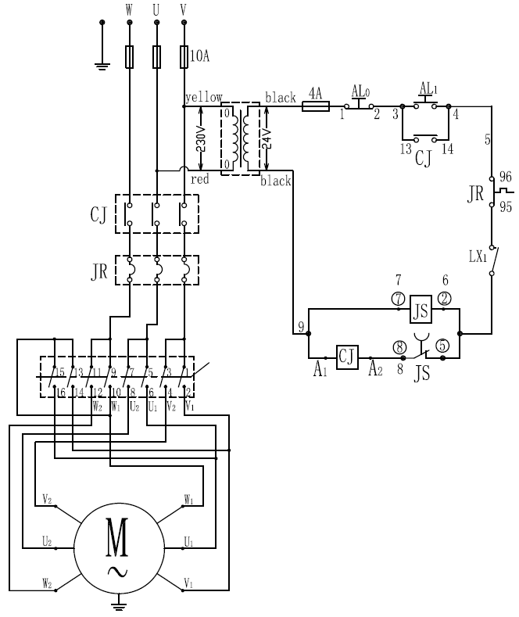
TECHNICAL PARAMETER SUBJECT TO CHANGE WITHOUT NOTICE
13
5.1.9 Three phases single speed Fixed Head Dough Mixer (Single speed) 380V/50Hz or 220V/60Hz, 24V Low Voltage Control, For DN10 to DN60 Series and DT10 to DT60 series
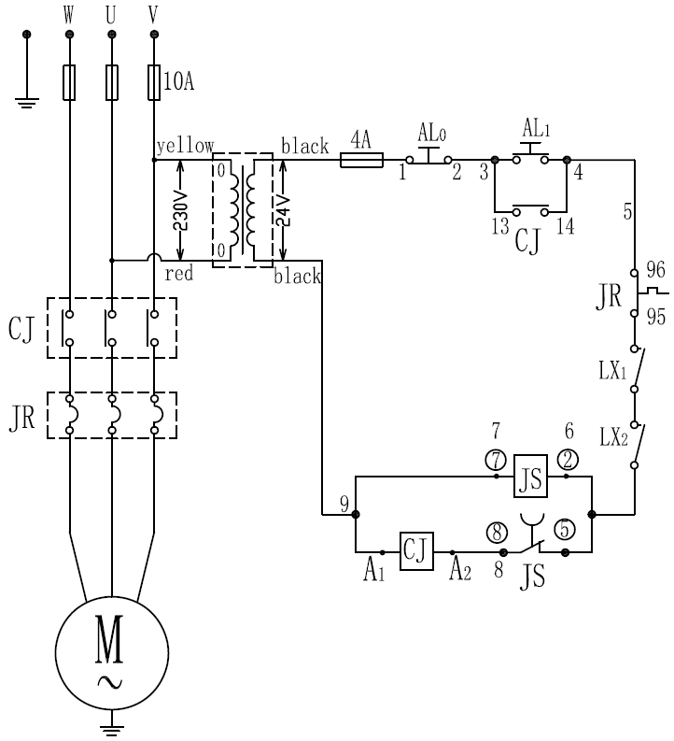
Annotations
CJ------ AC Contactor
JS---- Time relay
JR--- Overload Relay
AL₀---- Emergency switch
AL₁----- Start button
LX₁ LX₂------ Micro Switch
--------- Time relay contact point
5.1.10 Rising head dough mixer (Single speed) 380V/50Hz,24 V Low voltage control
For HTD-10 to HTD-50 series and HTT-10 to HTT-50 series
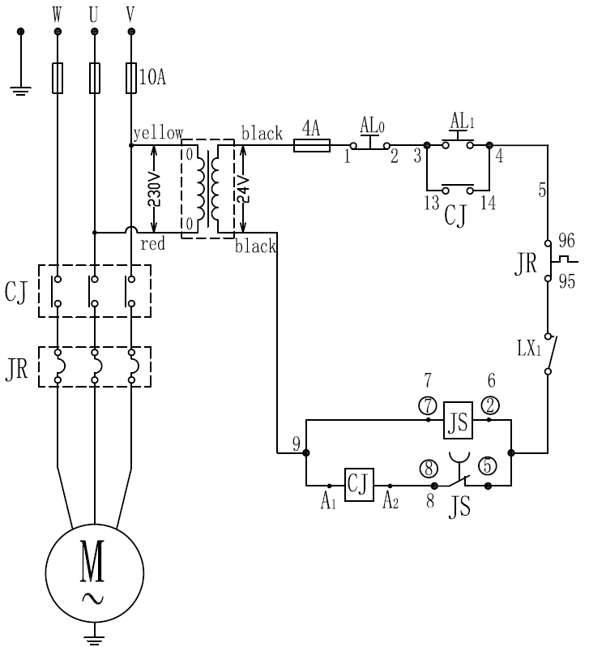
Annotations
CJ------ AC Contactor
JS---- Time relay
JR--- Overload Relay
AL₀---- Emergency switch
AL₁----- Start button
LX₁ LX₂------ Micro Switch
--------- Time relay contact point
TECHNICAL PARAMETER SUBJECT TO CHANGE WITHOUT NOTICE
14
5.1.11 Three phases Single speed Fixed Head Dough Mixer, 380V/50Hz or 220V/60Hz,
For DN10 to DN60 Series and DT10 to DT60 series
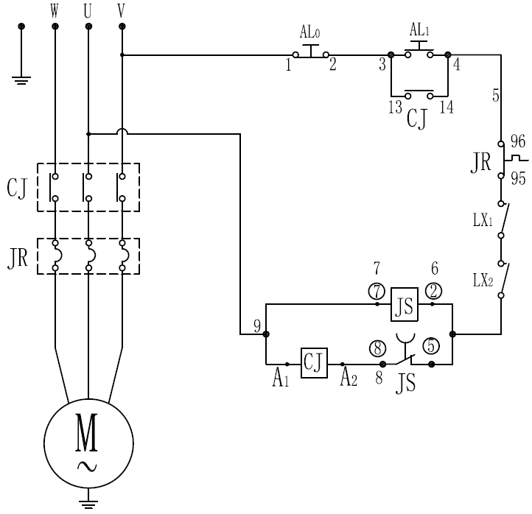
Annotations
CJ------ AC Contactor
JS---- Time relay
JR--- Overload Relay
AL₀---- Emergency switch
AL₁----- Start button
LX₁ LX₂------ Micro Switch
--------- Time relay contact point
5.1.12 Three phases Single speed Rising head dough mixer 380V/50Hz or 220V/60Hz
For HTD-10 to HTD-50 series and HTT-10 to HTT-50 series
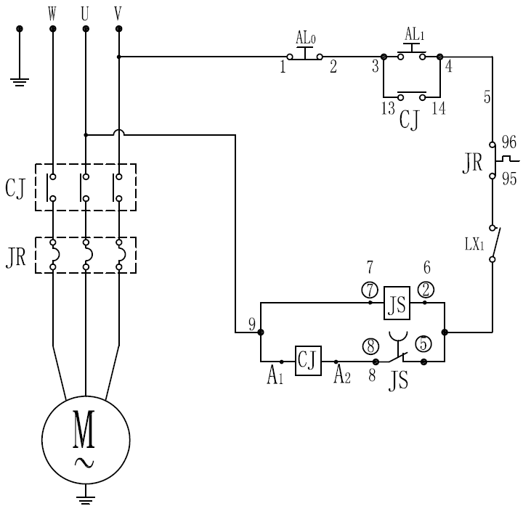
Annotations
CJ------ AC Contactor
JS---- Time relay
JR--- Overload Relay
AL₀---- Emergency switch
AL₁----- Start button
LX₁ LX₂------ Micro Switch
--------- Time relay contact point
TECHNICAL PARAMETER SUBJECT TO CHANGE WITHOUT NOTICE
15
5.2 Transformer （optional ）
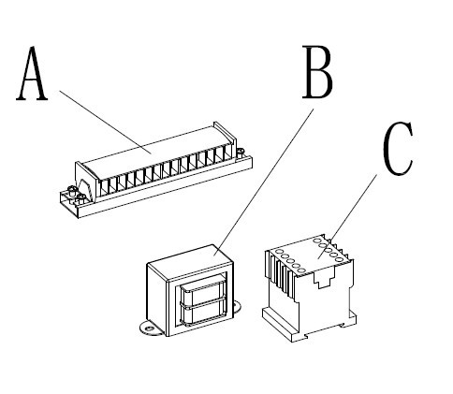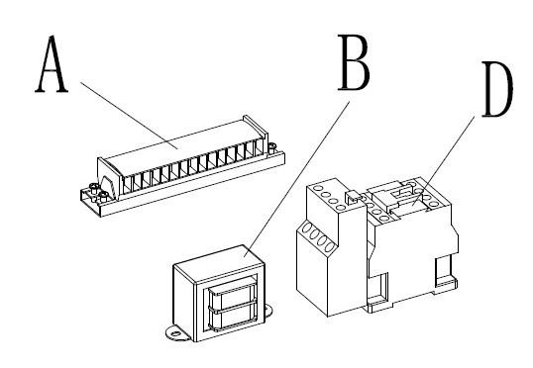
A-Terminal Block
B-Transformer
C-AC contactor
D-With thermal overload protection of AC contactor

TECHNICAL PARAMETER SUBJECT TO CHANGE WITHOUT NOTICE
16
5.3 Expolsive view and Part list
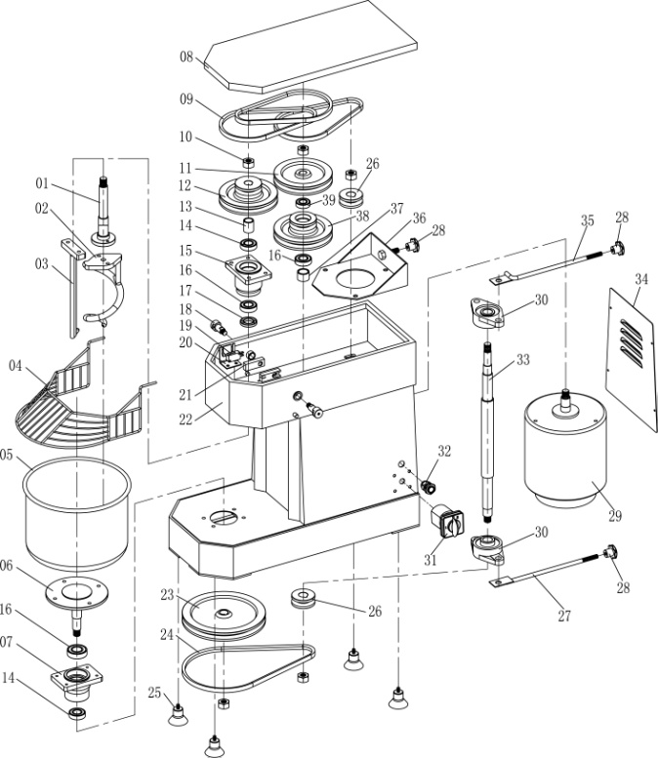
DN5
SN | Name | Q’ty |  | SN | Name | Q’ty
1 | Mixershaft | 1 |  | 21 | Block | 2
2 | Hook | 1 |  | 22 | Body | 1
3 | Mixing blade | 1 |  | 23 | Pulley | 1
4 | Lid (safety guard) | 1 |  | 24 | V belt | 1
5 | Bowl | 1 |  | 25 | Support feet | 4
6 | transmission plate | 1 |  | 26 | Pulley | 1
7 | bearing block ( for bowl ) | 1 |  | 27 | Transmission shaft Adjusting bar B | 1
8 | Top cover | 1 |  | 28 | Knob | 3
9 | V belt | 3 |  | 29 | Motor | 1
10 | Nut M14 | 5 |  | 30 | Bearing UCFL204 | 2
11 | Pulley B | 1 |  | 31 | reverse switch (on-off switch) | 1
12 | Nut M10 | 1 |  | 32 | Wire bush | 1
13 | Bush | 1 |  | 33 | Transmission shaft | 1
14 | Bearing 6003 | 2 |  | 34 | Back cover | 1
15 | Bearing block (for mixershaft) | 1 |  | 35 | Transmission shaft Adjusting bar A | 1
16 | Bearing 6004 | 3 |  | 36 | Adjusting board | 1
17 | Oil seal | 1 |  | 37 | Bush | 1
18 | Shaft ( for supporting lid ) | 2 |  | 38 | Pulley A | 1
19 | Micro switch | 1 |  | 39 | Bearing 6002 | 1
20 | Support for supporting micro switch | 1
TECHNICAL PARAMETER SUBJECT TO CHANGE WITHOUT NOTICE
17
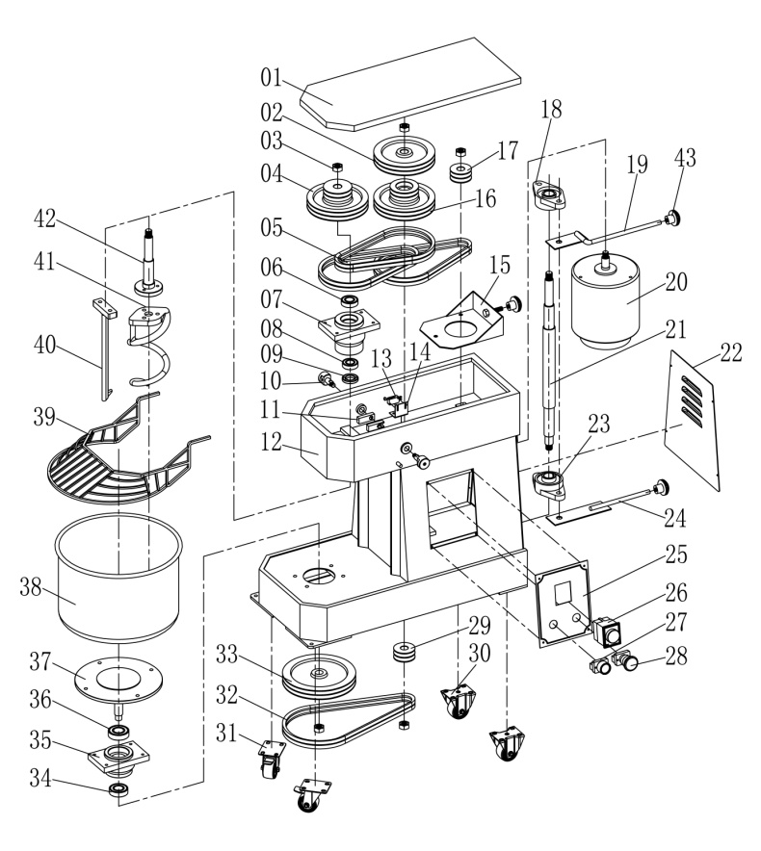
DN10
SN | Name | Q’ty |  | SN | Name | Q’ty
1 | Top cover | 1 |  | 24 | Transmission shaft Adjusting board B | 1
2 | Big Pulley A | 1 |  | 25 | Control plate | 1
3 | Nut M16 | 5 |  | 26 | Relay | 1
4 | Tower Pulley B | 1 |  | 27 | Start botton | 1
5 | V belt | 6 |  | 28 | Emergency stop switch | 1
6 | Bearing 6004 | 3 |  | 29 | Small pulley | 1
7 | Bearing block | 1 |  | 30 | Casters | 2
8 | Bearing 6005 | 2 |  | 31 | Casters with stopper | 2
9 | Oil seal | 1 |  | 32 | V belt | 2
10 | Bolts | 2 |  | 33 | Big pulley B | 1
11 | block | 2 |  | 34 | Bearing 6004 | 1
12 | body | 1 |  | 35 | Bearing block(for bowl) | 1
13 | Mirco switch | 1 |  | 36 | Bearing 6205 | 1
14 | Mirco switch support | 1 |  | 37 | Transmission plate | 1
15 | Adjusting board | 1 |  | 38 | Bowl | 1
16 | Tower Pulley A | 1 |  | 39 | Lid (safety guard) | 1
17 | Small pulley | 1 |  | 40 | Mixing blade | 1
18 | Bearing UCFL205 | 2 |  | 41 | Hook | 1
19 | Transmission shaft Adjusting board A | 1 |  | 42 | Mixershaft | 1
20 | Motor | 1 |  | 43 | Knob | 3
21 | Transmission shaft | 1
22 | Back cover | 1
23 | Bearing UCFL205 | 1

TECHNICAL PARAMETER SUBJECT TO CHANGE WITHOUT NOTICE
18
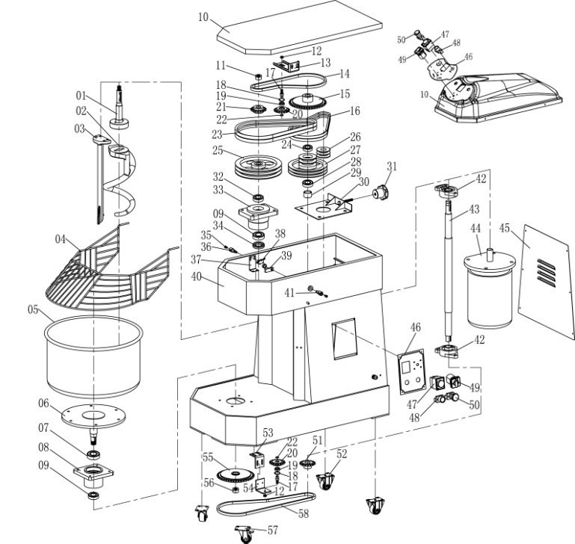
DN20(B)30(B )40(B)50(B)
DT20(B)30(B)40(B)50(B)
SN | Name | Q’ty |  | SN | Name | Q’ty
1 | Mixershaft | 1 |  | 30 | (adjusting board) | 1
2 | Hook | 1 |  | 31 | knob | 1
3 | Mixing blade | 1 |  | 32 | Bearing 6205 | 1
4 | Lid (safety guard) | 1 |  | 33 | (bearing block ( for mixer shaft ) | 1
5 | Bowl | 1 |  | 34 | Oil seal | 1
6 | transmission plate | 1 |  | 35 | Screws | 2
7 | Bearing 6207 | 1 |  | 36 | Bolts | 1
8 | bearing block ( for bowl ) | 1 |  | 37 | Support for supporting lid | 1
9 | Bearing 6206 | 2 |  | 38 | Microswitch | 1
10 | Top cover | 1 |  | 39 | Block | 2
11 | Nut M16 | 1 |  | 40 | Body | 1
12 | Nut M10 | 2 |  | 41 | Bolts | 1
13 | Tension gear Support Upper | 1 |  | 42 | Bearing UFCA206 | 2
14 | Drive chain Upper | 1 |  | 43 | Transmission shaft | 1
15 | Big Chain wheel ( for Transmission shaft | 1 |  | 44 | Motor | 1
16 | V belt A34 | 2 |  | 45 | Back cover | 1
17 | Axle for tension gear | 2 |  | 46 | Control plate | 1
18 | Ring 28# | 2 |  | 47 | Timer | 1
19 | Bearing 6001 | 2 |  | 48 | Start botton | 2
20 | Tension gear | 2 |  | 49 | Speed change –over switch | 2
21 | Small chain wheel (for mixershaft) | 2 |  | 50 | Emergency switch | 2
22 | Ring11# | 1 |  | 51 | Small chain wheel (for transmission shaft ) | 1
23 | V belt B39 | 2 |  | 52 | Casters | 2
24 | Bearing 6005 | 1 |  | 53 | Tension gear support A Lower | 1
25 | Big Pulley | 1 |  | 54 | Tension gear support B Lower | 1
26 | Pulley | 1 |  | 55 | bIg chain wheel (for bowl ) | 1
27 | Pulley | 1 |  | 56 | Nuts M24 | 1
28 | Bearing 6006 | 1 |  | 57 | Casters with stopper | 2
29 | Bush | 1 |  | 58 | Driven Chain Lower | 1

TECHNICAL PARAMETER SUBJECT TO CHANGE WITHOUT NOTICE
19
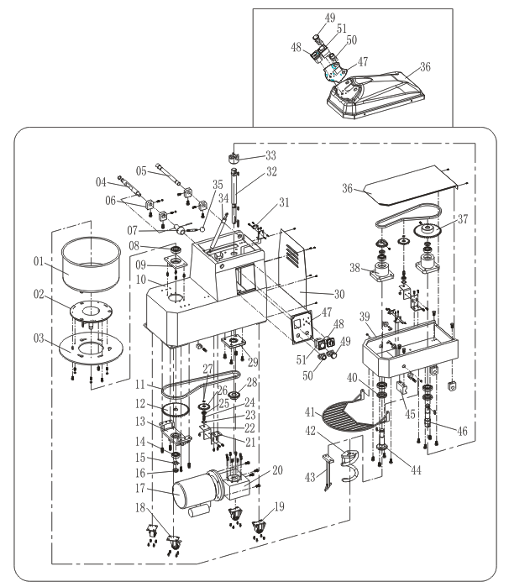
HTD SERIES20(B)30(B)40(B)
HTT SERIES20(B)30(B)40(B)

SN | Name | Q’ty |  | SN | Name | Q’ty
1 | Bowl | 1 |  | 27 | Ring | 1
2 | Transmission plate | 1 |  | 28 | Small chain wheel | 2
3 | Bowl locking plate | 1 |  | 29 | Bearing UCFU206 | 1
4 | Safety latch | 1 |  | 30 | Back cover | 1
5 | Gemel axis | 1 |  | 31 | Micro switch | 1
6 | hinge | 6 |  | 32 | Axle | 1
7 | Lock bolt seat | 1 |  | 33 | Drive coupling | 1
8 | Bearing 6206 | 3 |  | 34 | Air spring | 1
9 | Bearing seat | 1 |  | 35 | ball | 2
10 | Body lower | 1 |  | 36 | Top cover | 2
11 | Drive chain Lower | 2 |  | 37 | Chain wheel | 1
12 | Chain wheel | 1 |  | 38 | Bearingblock | 8
13 | Support | 1 |  | 39 | Body upper | 1
14 | Bearing 6205 | 3 |  | 40 | Oil seal | 2
15 | Washer | 1 |  | 41 | Lid (safety guard) | 1
16 | Nut M24*1.5 | 1 |  | 42 | Hiook | 2
17 | Motor | 1 |  | 43 | Mixing blade | 1
18 | Casters | 2 |  | 44 | Mixershaft | 1
19 | Casters with stopper | 2 |  | 45 | Block | 1
20 | Reduction box | 1 |  | 46 | Transmission shaft | 1
21 | Tension gear support A | 1 |  | 47 | Control plate | 1
22 | Tension gear support B | 1 |  | 48 | Speed change over switch | 1
23 | Ring | 2 |  | 49 | Emergency switch | 1
24 | Axle for tension gear | 2 |  | 50 | Start botton | 1
25 | Bearing 6001 | 2 |  | 51 | Timer | 1
26 | Tension gear | 2
TECHNICAL PARAMETER SUBJECT TO CHANGE WITHOUT NOTICE
20
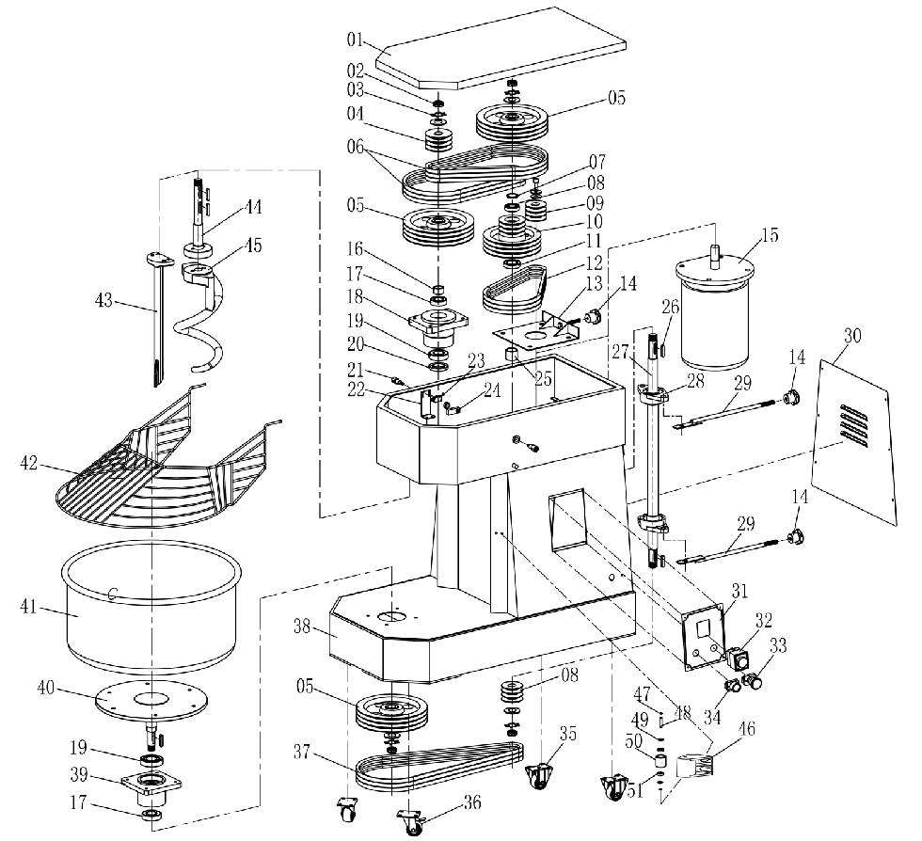
DN60

SN | Name | Q’ty |  | SN | Name | Q’ty
1 | Top cover | 1 |  | 27 | Transmission shaft | 1
2 | Nut M24*1.5 | 5 |  | 28 | Bearing UCFL207 | 2
3 | Gasket | 4 |  | 29 | Transmission shaft adjusting board | 2
4 | Belt SPA80-3 | 1 |  | 30 | Back cover | 1
5 | Belt SPA224-3 | 3 |  | 31 | Control Plate | 1
6 | V belt SPA1107 | 6 |  | 32 | Relay | 1
7 | Gasket | 1 |  | 33 | Emergency stop switch | 2
8 | Bearing 6006 | 1 |  | 34 | Start switch | 1
9 | Belt SPA63-3 | 2 |  | 35 | Casters | 2
10 | Stepped pulley SPA180/80-3 | 1 |  | 36 | Casters with stopper | 2
11 | Bearing 6007 | 1 |  | 37 | V belt SPA1432 | 3
12 | V belt SPA900 | 3 |  | 38 | Body | 1
13 | Adjusting board | 1 |  | 39 | Bearing block | 1
14 | Knob | 3 |  | 40 | Transmission plate | 1
15 | Motor | 1 |  | 41 | Bowl | 1
16 | Mixing shaft sleeve | 1 |  | 42 | Lid(safety guard) | 1
17 | Bearing 6207 | 1 |  | 43 | Mixing blade | 1
18 | Mixing bearing block | 1 |  | 44 | Mixer shaft | 1
19 | Bearing 6208 | 2 |  | 45 | Hook | 1
20 | Oil seal | 1 |  | 46 | Protect wheel frame | 2
21 | Bolts | 1 |  | 47 | Washer on shaft | 4
22 | Mirco switch support | 1 |  | 48 | Protect wheel shaft | 2
23 | Mirco switch | 1 |  | 49 | Protect wheel gaskets | 4
24 | Block | 1 |  | 50 | Protect wheel | 2
25 | Stepped pulley shaft sleeve | 1 |  | 51 | Bearing 6200 | 4
26 | Flat Key | 6
TECHNICAL PARAMETER SUBJECT TO CHANGE WITHOUT NOTICE
21
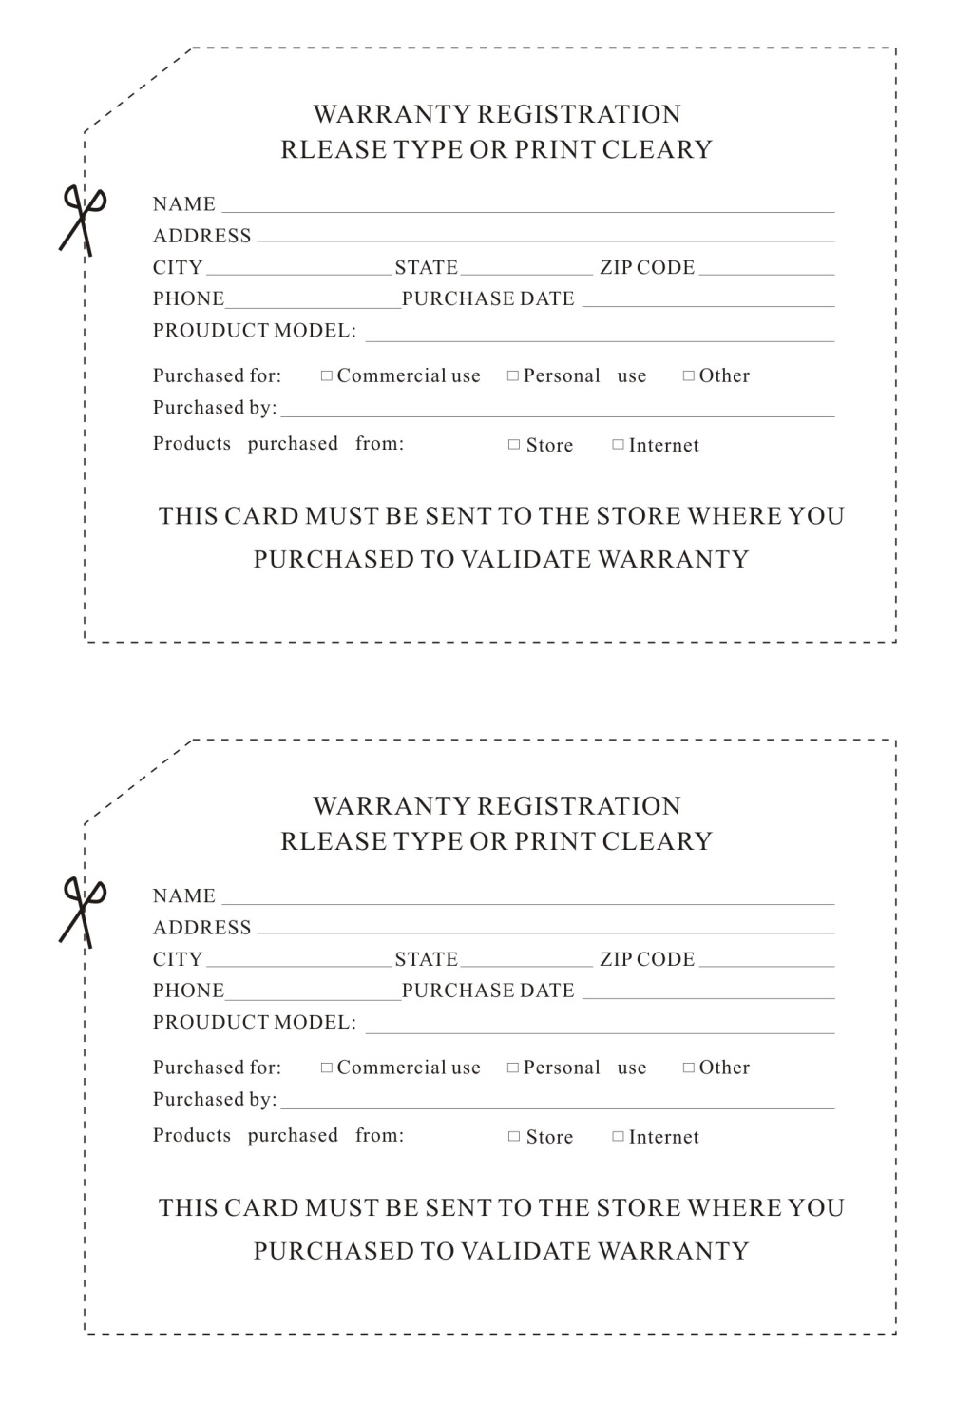

TECHNICAL PARAMETER SUBJECT TO CHANGE WITHOUT NOTICE
22

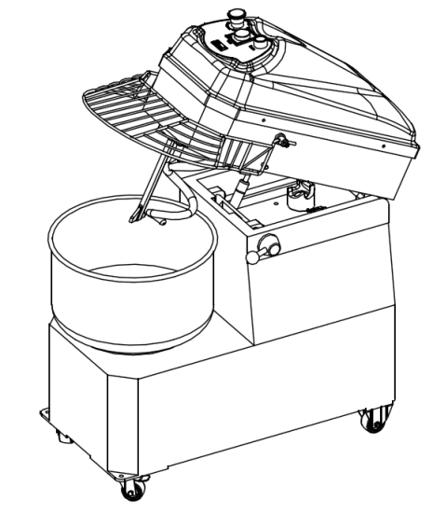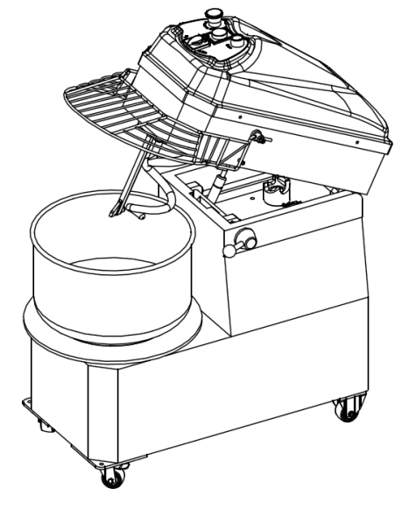
HTT-B SERIES DOUBLE SPEED RISED HEAD SPIRAL MIXER

HTT SERIES SINGLE SPEED RISED HEAD SPIRAL MIXER

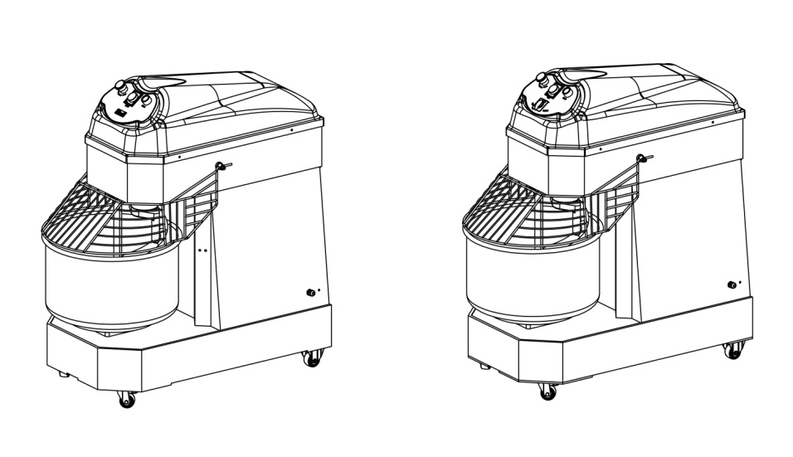
DT SERIES SINGLE SPEED FIXED HEAD SPIRAL MIXER

DT-B SERIES DOUBLE SPEED FIXED HEAD SPIRAL MIXER

TECHNICAL PARAMETER SUBJECT TO CHANGE WITHOUT NOTICE

